Research assignment presented in partial fulfilment for the requirements for the degree of MEng (Structured) (Industrial Engineering) in the Faculty of Engineering at Stellenbosch University
Supervisor: Prof. Evan Gilbert
December 2026

In Search of the Holy Grail of Factor Timing:
by
Cathy Catherine Hlungwani
Application of Machine Learning to the South African Equity Market

Declaration
By submitting this research assignment electronically, I declare that the entirety of the work contained therein is my own, original work, that I am the sole author thereof (save to the extent explicitly otherwise stated), that reproduction and publication thereof by Stellenbosch University will not infringe any third party rights and that I have not previously in its entirety or in part submitted it for obtaining any qualification.
During the preparation of this research assignment, the author used artificial Intelligent-assisted tool(s) to identify relevant literature, generate code, generate images, improve the readability and language of the thesis. After using the artificial intelligence-assisted tool(s), the author reviewed and edited the content and takes full responsibility for the content of the work.
Date: March 2026

Copyright © 2026 Stellenbosch University
All rights reserved
Abstract

Acknowledgements
xxxx

Contents
- Introduction 9
1.1 Background 10
1.2 Problem statement 12
1.3 Scope and objectives 12
1.4 Research methodology 13
1.5 Contribution to data science 14
1.6 Research assignment outline 15
- Literature Review 17
2.1 Foundational framework on factor timing 17
2.2 Machine Learning in Finance 20
2.3 Application of ML in factor timing strategies – Global context 26
2.4 Application of ML factor timing strategies – South African equity markets 30
- Methodology 32
3.1 Research design and empirical framework 32
3.2 Factor definitions 34
3.3 Motivation for using relative factor performance 35
3.4 Data sources and pre-processing 37
3.5 Trend-scanning target label construction 38
3.6 Feature selection 41
3.7 Model training 45
3.8 Hyperparameter tuning and model validation 51
3.9 Performance evaluation 54
3.10 Feature importance 56
- Results 58
4.1 Overview of the Evaluation Framework 58
4.2 The structure and dynamics of local style factors 58
4.3 Out-of-Sample predictive power 63
4.4 Feature Importance 73
4.5 Validation methodology impact 80
- Conclusion 87
- References 93
- Appendix A: Features Definitions 100
A.1: Market Data Feature Definitions 100
A.2: Fundamental Data Feature 101
A.3: Economic Data Feature Definitions 102
A.4. Relative Factor Interaction Metrics 103
- Appendix B: Feature Selection 104
B.1. Clusters and Cluster Representatives: 104
- Appendix C: CPCV and Walk-forward Formulation 105

List of Figures
Figure 1: Trend-scanning results each factor pairs 40
Figure 2: Hierarchical agglomeration clustering applied to the features space 42
Figure 3: CPCV back-test path, k=1 validation set, N=5 cv splits 52
Figure 4: Walk-forward validation with rolling look-back window 54
Figure 5: Cumulative factor returns 60
Figure 6: 12-month rolling factor returns 61
Figure 7: 52-week rolling correlations between factor pairs 63

List of Tables
Table 1: Classification of representative features with associated economic rationale and supporting empirical evidence 43
Table 2 Model comparison 50
Table 3: Key hyperparameters 52
Table 4: Spearman’s correlation 62
Table 5: Kendall’s tau 62
Table 6: OOS results for Momentum vs Value pairing 64
Table 7: Momentum vs Value - ROC-AUC across the three model specifications 65
Table 8: Momentum vs Value - Walk-forward predicted probabilities and realised outcomes 66
Table 9: OOS results for Momentum vs Quality pairing 67
Table 10: Momentum vs Quality - ROC-AUC across the three model specifications 68
Table 11: Momentum vs Quality - Walk-forward predicted probabilities and realised outcomes 69
Table 12: OOS results for Quality vs Value pairing 70
Table 13: Table 14: Value vs Quality - ROC-AUC across the three model specifications 71
Table 15: Value vs Quality - Walk-forward predicted probabilities and realised outcomes 72
Table 16: Comparative performance gains from machine learning models across factor pairs 73
Table 17: Comparative feature importance across model classes for momentum vs value 75
Table 18: Comparative feature importance across model classes for momentum vs quality 76
Table 19: Comparative feature importance across model classes for value vs quality 78
Table 20: Logistic - Best parameter combination set across walk-forward segments 81
Table 21: GAM - Best parameter combination set across walk-forward segments 83
Table 22: XGBoost - Best parameter combination set across walk-forward segments 84

List of acronyms and abbreviations
AI | Artificial Intelligence
AUC | Area Under the Curve
BRICS | Brazil, Russia, India, China, and South Africa
CAPM | Capital Asset Pricing Model
CART | Classification and Regression Trees
CPCV | Combinatorial Purged Cross-Validation
FY1 | Forward One-Year Earnings Estimate
GAM | Generalised Additive Model
GRU | Gated Recurrent Unit
LASSO | Least Absolute Shrinkage and Selection Operator
LSTM | Long Short-Term Memory Network
MAE | Mean Absolute Error
MI | Mutual Information
ML | Machine Learning
MSE | Mean Squared Error
NB | Nominal Bonds
OOS | Out-of-Sample
PC1 / PC2 | First / Second Principal Component
PR-AUC | Precision-Recall Area Under the Curve
QS | Quantile-Scaled Transformation
RB | Real Bonds
RMSE | Root Mean Squared Error
ROE | Return on Equity
ROIC | Return on Invested Capital
ROC | Receiver Operating Characteristic
ROC-AUC | Area Under the Receiver Operating Characteristic Curve
RNN | Recurrent Neural Network
SB | Structural Break Indicator
SHAP | Shapley Additive Explanations
TS | Time Series Level
XGBoost | Extreme Gradient Boosting
Ent | Entropy (market uncertainty measure)
EntDyn | Change in entropy
GretX | X-month geometric return
VolX | X-month rolling volatility
RV_X | X-month realised volatility

Introduction
Equity research identifies systematic differences in expected returns associated with company characteristics known as factors (Fama & French, 1992; Fama & French, 1993). Factors such as momentum, value, size, quality, profitability, and low volatility are widely documented sources of long-term return: momentum (Jegadeesh & Titman, 1993; Carhart, 1997), value (Fama & French, 1993), quality (Asness, Frazzini, & Pedersen, 2019; Piotroski, 2000), profitability (Fama & French, A five-factor asset pricing model, 2015) and low volatility (Blitz, Falkenstein, & van Vliet, 2014; Blitz D. C., 2007), with the momentum and value premia documented across markets and asset classes (Asness, Moskowitz, & Pedersen, 2013). These factors are well established in the international asset-pricing literature, but their realised returns vary materially over time (Daniel & Moskowitz, 2016; Barroso & Santa-Clara, 2015). This time variation creates an empirical motivation for factor timing. If changes in relative factor performance is partly predictable, investors may be able to dynamically allocate capital towards factors expected to outperformance (Arnott, Kalesnik, & Linnainmaa, 2023; Blitz, Falkenstein, & van Vliet, 2014).
The evidence supporting factor timing is mixed. Factor returns exhibit pronounced cycles and occasional crashes, and several studies report predictability from valuation, momentum or common factor signals (Daniel & Moskowitz, 2016; Gupta & Kelly, 2019; Haddad, Kozak, & Santosh, 2020). Other research finds that most factor timing relationships are weak, unstable or difficult to exploit consistently out of sample (Asness, Frazzini, & Pedersen, 2019; Ilmanen, Israel, Lee, Moskowitz, & Thapar, 2021; Asness, Chandra, Ilmanen, & Israel, 2017). The relevant empirical question is therefore whether a specified forecasting method produces reliable out-of-sample improvement, rather than whether factor timing is theoretically possible.
Classical econometric approaches have been a source of valuable insights in generating factor timing signals, but their reliance on linearity assumptions limits their ability to capture nonlinear interactions and complex market dynamics that may underpin short-run factor rotations (Cont, 2001; Campbell, Lo, & MacKinlay, 1997). Machine learning (‘ML’ hereafter) methods can account for these complexities and offer complementary perspectives to conventional approaches (Gu, Kelly, & Xiu, 2020; Giglio, Kelly, & Xiu, 2022; Wang, 2023; Moritz & Zimmermann, 2016). However, this greater flexibility also increases the capacity to fit noise. This concern is particularly important in finance, where predictive signals are weak, samples are limited and relationships may change over time (Harvey, Liu, & Zhu, 2016; Israel, Kelly, & Moskowitz, 2020; Arnott, Harvey, & Markowitz, 2019).
These issues are especially relevant in emerging equity markets. Greater informational inefficiency may leave more exploitable structure, but shorter data histories, higher idiosyncratic risk and more frequent structural breaks increase the risk that flexible models extract spurious patterns (Cakici, Fieberg, Metko, & Zaremba, 2023; Leung, Lohre, Mischlich, Shea, & Stroh, 2021). Although ML methods have shown predictive value in emerging-market return studies, their performance is not necessarily transferable across markets (Hanauer & Kalsbach, 2023). South African research documents persistent style effects and evidence of time variation, while recent studies have begun to examine style rotation using machine learning (Page, McClelland, & Auret, 2024; Makamo, 2023) (Mutooni & Muller, 2007; Page et al., 2022, 2024). However, limited evidence isolates the incremental contribution of nonlinearity and interaction effects under a common validation framework.
The study investigates the relative performance of value, momentum and quality within the South African equity market. This study formulates factor timing as a directional classification problem. For each pair of factors, the target identifies which factor subsequently exhibits the stronger trend. This formulation narrows the empirical task to the prediction of relative factor leadership and avoids requiring the models to estimate the magnitude of future returns.
Three model classes are compared. Logistic regression provides a regularised linear benchmark (Hosmer, Lemeshow, & Sturdivant, 2013) (Cox 1953). A generalised additive model (GAM) permits smooth nonlinear effects while retaining an additive structure (Hastie & Tibshirani, 1986; Hastie & Friedman, 2009). Extreme Gradient Boosting (XGBoost) represents the most flexible specification and can estimate nonlinear relationships and higher-order interactions (Chen & Guestrin, 2016; Hastie & Tibshirani, 1986; Hosmer, Lemeshow, & Sturdivant, 2013; Wood, 2017; Grinsztajn, Oyallon, & Varoquaux, 2022)
The three model classes constitute a systematic progression from a linear specification, through additive nonlinear effects, to a flexible tree-based model capable of representing higher-order interactions. This comparative framework enables an assessment of whether increasing functional flexibility produces consistent improvements in out-of-sample classification performance across the three factor pairs.
The combination of weak signals, a finite emerging-market sample and flexible model classes makes validation central to the research design. Backtests can overstate performance when model selection repeatedly uses the same observations or when training information overlaps with the period used for evaluation (Arnott et al., 2019; Israel et al., 2020). The study therefore separates hyperparameter selection from final out-of-sample evaluation and preserves the chronological ordering of the data.

Background
The empirical study of equity factors developed from the recognition that market beta alone does not explain the cross-section of expected returns. Foundational models like the Capital Asset Pricing Model (CAPM) provided a starting point (Lintner, 1965; Sharpe, 1964) to understanding the drivers of persistent equity returns. The subsequent expansion to multi-factor models confirmed that equity returns are driven by multiple sources of risk and return, including value, momentum, and quality (Fama & French, 1992; Fama & French, 2015; Carhart, 1997; Asness, Frazzini, & Pedersen, 2019). The economic origin of these premia remains debated, straddling rational risk-based (Fama & French, 1993; Fama & French, 2015) and behavioural bias-based explanations (Lakonishok, Shleifer, & Vishny, 1994; Daniel, Hirshleifer, & Subrahmanyam, 1998), suggesting that their drivers are multifaceted and not attributable to a single, unified theory.
Empirically, such factors do not offer consistent relative rewards but exhibit significant cyclicality and regime dependence, leading to prolonged periods of outperformance and deep drawdowns that challenge static, buy-and-hold factor investing (Ilmanen & Kizer, 2012; Daniel & Moskowitz, Momentum crashes, 2016; Bessler, 2021). The volatility in factor premia underpins the appeal of factor timing as a strategy to enhance returns (Arnott, Beck, Kalesnik, & West, 2016). Some studies report that even simple dynamic rules based on signals like valuation and momentum can improve risk-adjusted returns (Asness, Friedman, Krail, & Liew, 2000; Gupta & Kelly, 2019), while others find that valuation-based timing adds little beyond a static factor allocation (Asness, Chandra, Ilmanen, & Israel, 2017).

The South African setting provides a relevant but comparatively under-researched context. Value and momentum effects have long been documented on the Johannesburg Stock Exchange, and subsequent work has shown that local style returns vary through time (Fraser & Page, 2000; Mul-ler & Ward, 2013). Mutooni and Muller (2007) provide early evidence on equity style timing, while Page et al. (2022) examine style rotation and Page et al. (2024) apply tree-based machine-learning models to the same broad problem. This literature establishes the relevance of local factor timing, but it does not provide a controlled comparison of a linear model, an additive nonlinear model and an interaction-capable tree model using identical targets, predictors and evaluation periods.

Problem statement
This study addresses whether machine learning models can identify predictive signals in the relative performance of South African equity factors.. Existing local research provides limited evidence comparing models with different levels of flexibility using the same factor pairs, predictor set and time-series validation framework. This study therefore compares logistic regression, generalised additive models and XGBoost to determine whether greater model flexibility improves the out-of-sample prediction of relative momentum, value and quality performance.

Scope and objectives
The forecasting problem is defined in terms of the relative performance of three factor pairs: momentum versus value, momentum versus quality, and value versus quality, a formulation consistent with recent applications of ML to directional financial prediction (Cotturo, Liu, & Proner, 2024; Piovezan & de Andrea Jr., 2022). The empirical design draws on a broad data universe comprising historical market information, macroeconomic indicators, and factor-specific time-series inputs, reflecting evidence that both price-based and macro-state variables can influence factor premia (Gu, Kelly, & Xiu, 2020; Feng, Giglio, & Xiu, 2020). The study concentrates on statistical predictive performance rather than portfolio construction. It therefore does not claim that classification accuracy automatically translates into an implementable or profitable factor-rotation strategy. Transaction costs, portfolio turnover, market impact and probability-based allocation rules fall outside the primary empirical scope and are identified as areas for future research.
The primary objective of this study is to determine whether machine learning models with different levels of functional flexibility can predict the relative performance of momentum, value and quality factors in the South African equity market under a common time-series consistent evaluation framework. Within this scope, the study the following specific objectives:
- Construct pairwise classifications of relative factor leadership using trend-scanning labels for momentum versus value, momentum versus quality, and value versus quality.
- Implement a time-series-consistent validation framework combining combinatorial purged cross-validation for hyperparameter selection with expanding walk-forward evaluation of out-of-sample performance.
- Compare the out-of-sample predictive performance of logistic regression, generalised additive models and XGBoost, and assess whether greater model flexibility produces consistent improvements across the three factor pairs.
- Identify the features that most influence model predictions and examine how their importance varies across factor pairs and model classes.

Research methodology
The empirical design consists of three primary methodological components. Firstly, a sophisticated target labelling technique appropriate for financial datasets. Secondly, hierarchical comparison of model architectures. Lastly, a cross-validation methodology that preserves temporal ordering of data. We focus on predicting relative outperformance between factor pairs rather than return magnitudes.
The empirical analysis uses weekly factor return data spanning 2007–2025. These returns are combined with a broad set of lagged explanatory variables drawn from market, macroeconomic, valuation, sentiment, and volatility indicators. The inclusion of multi-domain predictors reflects evidence that factor premia are state-dependent and influenced by both price-based and macroeconomic conditions (Gu, Kelly, & Xiu, 2020; Feng, Giglio, & Xiu, 2020).
Binary labels are constructed using the trend-scanning methodology proposed by López de Prado (Lopez de Prado M. , 2018; Lopez de Prado M. , 2020). This approach allows the labelling process to adapt to varying market dynamics without imposing a fixed prediction window. Given the high dimensionality of the feature space, an information-theoretic clustering procedure based on mutual information is employed to reduce redundancy while preserving nonlinear dependencies (Lopez de Prado M. , 2018; Sulaiman & Labadin, 2016). This produces a compact and diversified predictor set appropriate for supervised learning.
To assess the incremental value of model flexibility, three progressively sophisticated model classes are compared: a linear logistic regression (Zou & Hastie, 2005; Hosmer, Lemeshow, & Sturdivant, 2013) , a semi-parametric GAM (Hastie & Tibshirani, 1986; James, Witten, Hastie, & Tibshirani, 2021), and a nonlinear tree-based method XGBoost (Friedman, 2001; Chen & Guestrin, 2016).
Model development and evaluation follow a temporally ordered validation framework designed to limit information leakage. Hyperparameters are selected using combinatorial purged cross-validation (‘CPCV’ hereafter) (Lopez de Prado M. , 2020). This technique addresses the risk of data leakage by generating multiple, distinct train/test splits. Crucially, for each split, it purges any training observations whose information horizon overlaps with the test set, ensuring that the model is never tested on data influenced by information used during training. The s
elected parameter configuration is then evaluated using a walk-forward procedure which approximates sequential real-time forecasting (Campbell, Lo, & MacKinlay, 1997).
Model performance is assessed using a set of complementary classification metrics, including average accuracy, the area under the receiver operating characteristic curve (ROC-AUC), and log-loss. Together these measures capture directional accuracy (average accuracy), ranking ability (ROC-AUC), and probability calibration (log-loss) (James, Witten, Hastie, & Tibshirani, 2021).
To further understand the structural drivers of model predictions, feature importance is analysed using Shapley value decompositions, which quantify the marginal contribution of each predictor while accounting for nonlinear interactions (Shapley, 1953). This approach has been widely applied in finance to enhance model interpretability and identify the most influential predictors across various applications (Lundberg & Lee, 2017; Molnar, 2022).
Through this integrated framework, the study evaluates the predictive performance, stability, and interpretability of machine learning models applied to factor timing, providing evidence on whether nonlinear modelling techniques offer meaningful advantages over traditional linear approaches in forecasting relative factor performance.

Contribution to data science
This study makes three principal contributions to applied data science and financial machine learning.
First, comparative modelling contribution. The study provides a comparison of linear, semi-parametric, and nonlinear machine learning models for factor timing within the South African equity market. This hierarchical evaluation of the three different model classes applied to the same observations, predictor set and evaluation period permits a direct assessment of whether additional functional flexibility improves out-of-sample generalisation.
Second, the study makes a methodological contribution by integrating trend-scanned binary labelling, mutual-information-based clustering for feature reduction, and combinatorial purged cross-validation for hyperparameter selection. Final out-of-sample performance is assessed using a walk-forward evaluation framework that preserves the temporal ordering of the data.
Third, the study uses global Shapley-value attribution to examine the information used by each fitted model. This provides an exploratory link between predictive model behaviour and economically motivated categories of market, macroeconomic, valuation, volatility, sentiment and factor-specific information.

Collectively, these contributions extend the international discourse on ML-driven dynamic allocation strategies while grounding the analysis in a methodologically disciplined framework.

Research assignment outline
The structure of this research assignment follows a systematic progression from theoretical foundations to empirical evaluation and synthesis of findings. Each chapter builds upon the preceding discussion to ensure conceptual coherence and methodological continuity.
Chapter 1 - Introduction: This chapter establishes the context and motivation for the study. It introduces the theoretical and empirical background to equity factor premia and machine learning–based factor timing, formulates the research problem, and defines the objectives and scope of the investigation. The chapter further presents an overview of the research design and methodological framework, and articulates the study’s contribution to data science

Chapter 2 – Literature Review: Chapter 2 situates the research within the broader academic literature. It reviews the foundational theory of factor premia and the evolution of factor timing strategies, followed by a structured examination of machine learning applications in asset pricing. Particular attention is given to empirical evidence from developed and emerging markets, methodological challenges such as nonlinearity and regime dependence, and concerns regarding overfitting and economic interpretability. The chapter concludes by identifying the research gap addressed by this study, particularly in the context of the South African equity market.
Chapter 3 – Methodology: We presents the empirical framework and modelling strategy adopted in the study. It details the construction of the momentum, value, and quality factors, and motivates the relative factor timing formulation. The chapter further outlines the data sources, preprocessing procedures, trend-scanning label construction, and mutual-information–based feature selection process. The specifications of the three model classes are formally introduced, followed by a description of the hyperparameter optimisation procedure using CPCV and the rolling walk-forward evaluation framework. Performance metrics and Shapley-based interpretability analysis are also defined. Collectively, this chapter establishes the statistical safeguards implemented to mitigate look-ahead bias, temporal leakage, and overfitting.
Chapter 4 – Research Results: This chapter presents the out-of-sample empirical findings. It begins with an analysis of the dynamics and dependence structure of the selected style factors. Thereafter, the comparative predictive performance of the three modelling approaches is evaluated using complementary classification metrics. The chapter further examines robustness across validation windows and investigates feature importance to assess structural model behaviour. The findings are interpreted in light of economic significance and the trade-off between model flexibility and generalisation.
Chapter 5 – Conclusions and Recommendations: The final chapter synthesises the principal findings of the study and evaluates whether machine learning methods enhance the timing of relative factor performance in the South African equity market. It summarises the key empirical insights, reflects on the incremental value of model complexity, and discusses the broader implications for quantitative asset management and emerging market applications. The chapter concludes by outlining the study’s limitations and proposing directions for future research, including portfolio implementation considerations and regime-sensitive model extensions.

Literature Review

Foundational framework on factor timing
The foundation of equity factor research lies in the Capital Asset Pricing Model (CAPM), developed by (Lintner, 1965) and (Sharpe, 1964) which attributes equity returns solely to market risk, positing that investors earn a premium for bearing undiversifiable risk. Subsequently, empirical anomalies demonstrated that while influential, single-factor models could not adequately explain persistence patterns in returns. While (Fama & French, 1992) acknowledges market risk as a driver of returns, they introduced size and value premia to augment the market risk factor. They demonstrated that smaller firms (size factor) and stocks with high book-to-market ratios (value stocks) earn higher returns, unexplained by the CAPM model. Following the findings of (Jegadeesh & Titman, 1993) who showed that stocks with strong recent performance tend to continue outperforming, (Carhart, 1997) incorporated the momentum factor to the Fama-French 3-factor model. Fama & French would later extend the 3-factor model to include profitability and investment factors, reflecting corporate fundamentals linked to long-horizon expected returns (Fama & French, A five-factor asset pricing model., 2015). Over the last decade, asset pricing research continued to uncover a rapidly expanding set of cross-sectional return predictors. This proliferation of factors often referred to as the factor zoo (Cochrane, 2011), is partially attributed to insufficiently stringent statistical controls in academic testing, with many factors lacking economic justification and fail to replicate in out-of-sample testing (Feng, Giglio, & Xiu, 2020). Nevertheless, a core set of factors;value, size, momentum, profitability, low-risk, and investmentare widely regarded as academically validated (Harvey, Liu, & Zhu, 2016) and economically interpretable (Fama & French, 2015; Jegadeesh & Titman, 1993; Blitz D. C., 2007).
The foundation of equity factor research lies in the Capital Asset Pricing Model (CAPM), developed by (Sharpe, 1964) and (Lintner, 1965), which attributes expected equity returns solely to market risk, positing that investors earn a premium only for bearing undiversifiable risk. Subsequent empirical anomalies demonstrated that, while influential, single-factor models could not adequately explain the cross-section of returns. (Fama & French, 1992) retained market risk as a driver of returns but showed that smaller firms (the size effect) and stocks with high book-to-market ratios (value stocks) earn higher returns than the CAPM predicts, and (Fama & French, 1993) formalised these effects in their three-factor model. (Jegadeesh & Titman, 1993) showed that stocks with strong recent performance tend to continue outperforming, and (Carhart, 1997) added this momentum factor to the three-factor model. (Fama & French, 2015) later extended their model with profitability and investment factors, reflecting corporate fundamentals linked to long-horizon expected returns, while related work documented quality (Asness, Frazzini, & Pedersen, 2019) and low-volatility (Blitz D. C., 2007) premia. Over the last decade, asset pricing research has continued to uncover a rapidly expanding set of cross-sectional return predictors. (Cochrane, 2011) described this proliferation as a “zoo” of factors, and subsequent work attributes it partly to insufficiently stringent statistical standards. Many proposed factors lack economic justification and fail to replicate out of sample (Harvey, Liu, & Zhu, 2016; Feng, Giglio, & Xiu, 2020). Nevertheless, a small core set of factors (value, size, momentum, profitability, low risk and investment) remains widely used in both research and practice (Asness, Moskowitz, & Pedersen, 2013; Fama & French, 2015). This study focuses on three of these factors in the South African context: value, momentum and quality.

This study focuses on three of these academically validated factors: value, momentum, and quality in the South African context.
Although the empirical existence of factor premia is well established, their economic origin remains contested. The persistence of factor returns has been explained through two competing, but non-mutually exclusive perspectives. The rational finance perspective proposes that factor premia compensate investors for bearing fundamental, non-diversifiable macroeconomic risks (Fama & French, 1993; Fama & French, 2015). While the behavioural finance perspective attributes these premia to systematic investor biases such as overreaction or extrapolation, that cause behavioural premia to persist (Lakonishok, Shleifer, & Vishny, 1994; Daniel, Hirshleifer, & Subrahmanyam, 1998). The critical mechanism allowing these behavioural anomalies to persist stems from limitations to arbitrage, where real-world constraints prevent the efficient elimination of mispricing (Shleifer & Vishny, 1997). If these two empirically supported explanations exist, factor premia are unlikely to have a single unified origin. While some premia may be largely compensatory for macroeconomic risks (Fama & French, 2015), others may be more strongly influenced by persistent behavioural biases (Daniel, Hirshleifer, & Subrahmanyam, 1998). Regardless of the origins of factor premia, factor returns appear to be influenced by complex and multi-faceted variables that extend beyond economic fundamentals.
Although the theoretical underpinnings of factor premia remain contested, their documented persistence in empirical research has spurred significant interest in constructing portfolios to harvest these risk premia. A naïve diversification strategy where capital is allocated equally across factors could potentially harvest long-term premia, and (DeMiguel, Garlappi, & Uppal, 2009) show that such equal weighting is difficult to beat out of sample when allocating across assets. However, factor returns tend to be highly cyclical, exhibiting prolonged periods of outperformance and underperformance, often lasting several years and not straightforwardly attributable to macro-economic cycles (Ilmanen & Kizer, 2012; Bessler, 2021; Daniel & Moskowitz, 2016). The recurrence of value crashes and growth rallies in empirical history suggests that even a diversified factor portfolio can endure multi-year underperformance depending on regime shift (Asness, Friedman, Krail, & Liew, 2000; Arnott, Beck, Kalesnik, & West, 2016). While factors are regime dependent and predisposed to multi-year drawdowns, their cycles are typically asynchronous, suggesting that dynamic reallocation across factors could improve risk-return outcomes relative to static diversification (Ilmanen & Kizer, 2012).
This insight underpins the concept of factor timing. Dynamically overweighting factors expected to outperform in the near future while simultaneously underweighting underperformers, can potentially enhance returns and, crucially, mitigate the deep, regime-dependent drawdowns that plague static portfolios (Arnott, Beck, Kalesnik, & West, 2016).
Some studies report that valuation and momentum-based timing rules improve risk-adjusted performance relative to static allocations (Asness, Friedman, Krail, & Liew, 2000; Gupta & Kelly, 2019)(Asness, Friedman, Krail, & Liew, 2000; Gupta & Kelly, 2019; Huang, Li, Wang, & Zhou, 2020). Other evidence finds that timing gains are sensitive to the predictor, evaluation period, benchmark and treatment of implementation costs (Asness, Chandra, Ilmanen, & Israel, 2017; Ilmanen, Israel, Lee, Moskowitz, & Thapar, 2021)(Asness et al., 2017; Cederburg et al., 2020; Ilmanen et al., 2021). The literature therefore supports testing factor timing out of sample rather than assuming that reported full-sample gains will persist.
(Cotturo, Liu, & Proner, 2024) identify several difficulties in forecasting factor premia. Their eco-nomic drivers are incompletely understood and may reflect financial and macroeconomic variables operating over different horizons. The relationship between predictors and factor performance may also be nonlinear and interactive (Gu, Kelly, & Xiu, 2020; Leung, Lohre, Mischlich, Shea, & Stroh, 2021), while the relationships themselves can change across market states (Ilmanen, Israel, Lee, Moskowitz, & Thapar, 2021). These features motivate the comparison of models with different levels of functional flexibility, but do not imply that the most flexible model will perform best.

The structural challenges inherent in timing factor premia have led recent research to explore the use of Machine Learning (ML) methods. ML approaches do not require the pre-specification of a functional form, allowing them to approximate complex, nonlinear relationships between predictors and asset returns (Gu, Kelly, & Xiu, 2020). A growing body of evidence shows that factor returns are influenced by interaction effects and nonlinear dynamics that linear models struggle to capture (Leung, Lohre, Mischlich, Shea, & Stroh, 2021; Bryzgalova, Pelger, & Zhu, 2023). ML methods are also designed to operate effectively in high-dimensional environments, where the number of potential predictors may be large relative to the sample size (Feng et al., 2018; Rapach & Zhou, 2013). Furthermore, several studies find that market conditions and factor behaviour evolve over time in ways that favour more flexible, adaptive modelling frameworks (Ilmanen, Israel, Lee, Moskowitz, & Thapar, 2021). Considering these empirical findings, ML techniques are well suited for modelling the nonlinear, high-dimensional and regime-dependent features that characterise factor timing problems (Cotturo, Liu, & Proner, 2024).

Machine Learning in Finance
ML is a branch of artificial intelligence (‘AI’ hereafter) concerned with algorithms whose performance on a task improves with experience, that is, with exposure to data, rather than through explicitly programmed rules (Mitchell, 1997; Bishop, 2006). While traditional econometric approaches that rely on pre-specified functional forms, ML methods emphasise flexible function approximation, statistical learning theory, and generalisation to unseen data (Bishop, 2006; James, Witten, Hastie, & Tibshirani, 2021). These properties have motivated their growing adoption in financial economics. The central econometric challenge in factor timing is modelling the dynamic, and potentially nonlinear, relationship between predictive signals (macroeconomic, valuation, or sentiment indicators) and the future returns of a factor style portfolio (Cotturo, Liu, & Proner, 2024; Cochrane, 2011). The choice of model family fundamentally determines what kind of relationships can be uncovered. ML literature commonly categorises learning paradigms according to the nature of the available information and the learning objective (Bishop, 2006; Hastie, Tibshirani, & Friedman, 2009; Sutton & Barto, 2018):
- Supervised learning refers to a family of predictive modelling techniques in which algorithms learn a mapping from input variables (predictors) to an output variable (label) using historical data. Formally grounded in statistical learning theory, supervised learning is framed as a risk minimisation problem in which model parameters are estimated by minimising an expected loss function, often subject to regularisation to control model complexity and improve generalisation (Hastie & Friedman, The Elements of Statisitcal Learning, 2009; Vapnik, 1999). The parameters are estimated from historical examples of inputs and outcomes and then used to predict outcomes for new inputs (James, Witten, Hastie, & Tibshirani, 2021).
- Unsupervised learning, by contrast, involves algorithms that learn patterns and structures from input data without any labelled outcomes or supervision (Jain, Murty, & Flynn, 1999; Bishop, 2006). Rather than predicting a response variable, these methods aim to model the underlying distribution, geometry, or dependency structure of the input space. Typical tasks include clustering and dimensionality reduction (Jain, Murty, & Flynn, 1999).
- Reinforcement learning represents a distinct goal-oriented learning paradigm where an autonomous agent learns to make decisions by performing actions in an environment to maximize a cumulative reward signal (Sutton & Barto, 2018). The agent learns a policy, a rule that maps states to actions, by trial and error. Reinforcement learning is particularly suited to control and sequential decision problems but is typically more complex and data-intensive than supervised or unsupervised approaches.
Within supervised learning, literature distinguishes between model families according to their functional flexibility, interpretability, and capacity to capture nonlinear interactions. Regularised linear models, semi-parametric methods, tree-based ensembles, and deep learning architectures occupy distinct positions along this spectrum, reflecting trade-offs between transparency, robustness, and expressive power (Bishop, 2006; Gu, Kelly, & Xiu, 2020). This body of work provides the conceptual foundation for the model families considered in this study.

Regularised & Semi-Parametric models
A central concern in empirical return prediction is the instability of parameter estimates in the presence of high-dimensional and strongly correlated predictors, a feature that is particularly pronounced in macro-financial datasets (Hastie & Friedman, 2009). Statistical literature addresses this challenge through regularisation, which constrains model complexity by penalising large coefficient estimates, thereby reducing variance and improving out-of-sample generalisation (Vapnik, 1999).
Early contributions such as ridge regression introduced an ℓ₂ penalty stabilise linear models under multicollinearity by shrinking coefficients toward zero without eliminating predictors (Hoerl & Kennard, 1970). The LASSO extended this framework by applying an ℓ₁ penalty that induces sparsity by setting some coefficients exactly to zero, facilitating variable selection and interpretability (Tibshirina, 1996). Subsequent research highlighted limitations of pure ℓ₁ regularisation in environments with highly correlated predictors, motivating the elastic net, which combines ℓ₁ and ℓ₂ penalties to balance sparsity and stability (Zou & Hastie, 2005).
While regularisation addresses estimation instability, linear models remain limited by their global linear functional form. This limitation motivated the development of semi-parametric models, such as Generalised Additive Models (GAMs), which extend linear predictors by replacing fixed coefficients with smooth, data-driven functions of individual covariates (Hastie & Tibshirani, 1986). By allowing nonlinear marginal effects while preserving additivity, GAMs capture economically intuitive relationships without resorting to fully nonparametric complexity. Penalised regression splines are used to control smoothness and prevent overfitting, positioning GAMs as an intermediate class between linear and fully nonlinear models (Wood, 2017). As such, GAMs provide an interpretable yet flexible framework for modelling gradual, regime-dependent dynamics in financial time series.

Tree-Based Models
Within supervised learning, tree-based models represent a further departure from parametric and semi-parametric specifications by learning nonlinear decision rules through recursive partitioning of the predictor space (Breiman, Friedman, Olshen, & Stone, 1984; Hastie & Friedman, 2009). The aim is to create partitions that are as pure as possible with respect to the target variable, typically evaluated using measures such as Gini impurity or entropy. These models construct interactions and threshold effects endogenously from the data, allowing for locally adaptive relationships between predictors and outcomes. This flexibility makes tree-based methods particularly well suited to capturing regime shifts and higher-order interactions that are difficult to model using linear or additive frameworks.
Early studies documented that single decision trees suffer from high variance and limited out-of-sample robustness, often fitting noise rather than persistent structure (Breiman, Friedman, Olshen, & Stone, 1984). To address these shortcomings, the literature developed ensemble methods that aggregate information across multiple trees. Random forests employ bootstrap aggregation and random feature selection to decorrelate individual trees, yielding more stable and robust predictions (Breiman, 2001). Gradient boosting methods construct trees sequentially, with each iteration focusing on correcting the errors of the existing ensemble through gradient-based optimisation of a loss function (Friedman, 2001). Subsequent innovations such as XGBoost and LightGBM introduced regularisation, shrinkage, and computational optimisations that significantly improved performance and scalability, leading to their widespread adoption in empirical finance and asset pricing research (Chen & Guestrin, 2016; Ke, et al., 2017).
Within the empirical asset-pricing literature, tree-based ensemble methods are frequently characterised by competitive predictive performance in some settings and ability to model complex nonlinear interactions, albeit at the cost of reduced interpretability and increased sensitivity to model tuning relative to linear and semi-parametric approaches (Gu, Kelly, & Xiu, 2020).

Deep learning and hybrid models
Deep learning architectures extend nonlinear function approximation through multiple layers and can represent complex relationships in high-dimensional data (Goodfellow, Bengio, & Courville, 2016). Unlike earlier model classes, deep neural networks employ multiple layers of nonlinear transformations that allow features to be learned hierarchically from the data, rather than being manually specified or implicitly constructed through tree splits. This expressive capacity has driven their increasing adoption in empirical finance, particularly in settings characterised by weak signals, evolving regimes, and complex interaction structures (Gu, Kelly, & Xiu, 2020).
Feedforward neural networks (FNNs) constitute the foundational deep learning architecture and represent a direct extension of nonlinear function approximation within supervised learning (Goodfellow, Bengio, & Courville, 2016). In empirical finance, this flexibility has made neural networks attractive tools for modelling nonlinear predictor interactions and high-dimensional return structures in asset pricing and return prediction problems. Recent studies report that neural network architectures can capture complex interactions among firm characteristics, macroeconomic variables, and style factors that traditional linear models fail to identify (Gu, Kelly, & Xiu, 2020; Chen, Pelger, & Zhu, 2019; Feng, He, Polson, & Xu, 2023). However, because FNNs treat observations as conditionally independent, they do not explicitly model temporal dependence, and their effectiveness in time-series applications often hinges on the quality of engineered lagged inputs or summary features (Goodfellow, Bengio, & Courville, 2016).
To address the inability of feedforward architectures to model temporal dependence directly, the literature introduced recurrent neural networks (RNNs), which incorporate feedback connections that allow information to persist across time steps (Rumelhart, Hinton, & Williams, 1986). This architectural feature enables RNNs to model sequential dependence and dynamic evolution, making them conceptually well suited to financial time series and factor premia that exhibit persistence, reversals, and regime shifts (Gu, Kelly, & Xiu, 2020; Fischer & Krauss, 2018). Early empirical studies, however, documented practical limitations of standard RNNs arising from vanishing and exploding gradient problems, which impede learning of long-horizon dependencies (Bengio, Simard, & Frasconi, 1994).
Subsequent advances addressed these limitations through gated architectures such as Long Short-Term Memory (LSTM) networks (Hochreiter & Schmidhuber, 1997) and Gated Recurrent Units (GRUs) (Chung, Gulcehre, Cho, & Bengio, 2014). By introducing gating mechanisms that regulate information flow and memory retention, these models significantly improve the ability to learn long-range temporal dependencies. Within the financial literature, LSTM and GRU architectures have been applied to persistence and nonlinear dynamics in asset returns, although their performance is context dependent and their complexity reduces interpretability relative to simpler learners (Fischer & Krauss, 2018; Krauss, Do, & Huck, 2017; Sirignano & Cont, 2019; Lim & Zohren, 2021).
More recently, transformer architectures have emerged as a powerful alternative to recurrent models for sequence modelling (Vaswani, et al., 2017). Transformers replace recurrence with self-attention mechanisms that explicitly quantify the relevance of past observations when forming predictions. This design enables the modelling of long-range dependencies and complex interaction structures while allowing for parallel computation, substantially improving training efficiency. Although initially developed for natural language processing, transformers have increasingly been applied in financial forecasting and market prediction tasks, where they offer a mechanism for representing nonlocal temporal relationships and cross-feature interactions (Lim & Zohren, 2021).
Alongside advances in deep learning, the literature has emphasised the value of hybrid and ensemble learning frameworks that combine the strengths of multiple model classes. Model combination approaches aggregate predictions from heterogeneous learners to improve predictive robustness and reduce sensitivity to model-specific assumptions (Dietterich, 2000; Sagi & Rokach, 2018). Stacked generalisation, in particular, integrates heterogeneous base learners, ranging from linear and semi-parametric models to tree-based and neural architectures, through a meta-learner that optimally combines their predictions (Wolpert, 1992).
The diversity of modelling approaches discussed above reflects the broader econometric challenge of forecasting time-varying factor premia in the presence of high-dimensional and potentially nonlinear predictive signals. While traditional linear asset pricing models provide a useful benchmark, growing evidence suggests that the drivers of factor returns may exhibit complex interaction effects, regime dependence, and nonlinear responses to macro-financial conditions (Cochrane, 2011; Gu, Kelly, & Xiu, 2020). These characteristics have motivated a growing body of research that applies machine learning techniques to the problem of factor timing, where predictive models forecast changes in relative factor performance using economic and market information.

Application of machine learning to factor timing in the global literature

Challenges with time-series data:
Literature establishes that momentum, value and quality are economically distinct factor premia whose relative performance varies through time (Jegadeesh & Titman, 1993; Fama & French, 1993; Fama & French, 2015; Asness, Moskowitz, & Pedersen, 2013; Ilmanen, Israel, Lee, Moskowitz, & Thapar, 2021). Their cyclical behaviour provides the motivation for factor timing (Gupta & Kelly, 2019), but it does not imply that changes in factor leadership are easily predictable. Factor returns exhibit low signal-to-noise ratios, meaning the predictable component of factor returns is small relative to the unexplained component..
Predictive relationships shift over time. Predictors that work over full samples often fail in later subperiods (Welch & Goyal, 2008), and premia shrink after publication (McLean & Pontiff, 2016). Factor behaviour also changes with market states, as momentum crashes show (Daniel & Moskowitz, 2016). On the JSE, size and momentum premia vary with the business cycle (Kapche Fotso, 2019). A relationship learned in one regime may not hold in the next.
Timing results depend on which predictors are tested and how performance is judged. Testing many specifications inflates the best result (Harvey, Liu, & Zhu, 2016) (White, 2000; Harvey et al., 2016). Valuation-based timing illustrates predictor sensitivity. (Arnott, Beck, Kalesnik, & West, 2016) find it useful, while (Asness, Chandra, Ilmanen, & Israel, 2017) find it adds little beyond a static value tilt. Evaluation design also matters. Gains found in full-sample tests often vanish out of sample (Cederburg et al., 2020), and JSE style-rotation alphas largely disappear once momentum is added to the benchmark (Page, McClelland, & Auret, 2024).

Model complexity trade-offs
The selection of an ML model for factor timing involves a critical trade-off between predictive sophistication and practical utility. Complex models such as LSTMs offer substantial functional flexibility for capturing intricate nonlinear and temporal dependencies (Krauss, Do, & Huck, 2017; Ma, Liao, & Jiang, 2023). However, the practical implementation of highly complex models in investment strategies introduces several challenges. These models can be sensitive to tuning and sample variation, when converted into trading signals, unstable predictions may also increase turnover and transaction costs (Panda, Gharanchaei, Chen, & Lyu, 2024). Furthermore, their performance is highly sensitive to market microstructures, such as data quality, liquidity, and idiosyncratic risk, making them less robust across diverse global markets (Cakici, Fieberg, Metko, & Zaremba, 2023; Leung, Lohre, Mischlich, Shea, & Stroh, 2021).
Tree-based models such as random forests and XGBoost provide a different trade-off between flexibility and robustness. They can represent nonlinearities and interactions without the parameter count associated with many deep-learning architectures. Empirical studies report competitive performance in some factor-timing applications, but the results remain dependent on the market, sample, tuning procedure and evaluation design(Panda, Gharanchaei, Chen, & Lyu, 2024; Cakici, Fieberg, Metko, & Zaremba, 2023).
More broadly, combination methods represent a pragmatic solution to the complexity–robustness trade-off inherent in financial prediction problems. By combining multiple models, they aggregate diverse predictive patterns, potentially improving out-of-sample robustness and mitigating the risk of over-reliance on any single, potentially unstable, complex model (Krauss, Do, & Huck, 2017; Cakici, Fieberg, Metko, & Zaremba, 2023). In environments characterised by weak and unstable predictive signals—such as factor return forecasting—this aggregation can improve out-of-sample robustness by reducing variance and mitigating overfitting (Dietterich, 2000; Gu, Kelly, & Xiu, 2020).
Consequently, the marginal benefits of increasingly complex models may diminish, or even turn negative, in practical portfolio applications. Empirical evidence suggests that simpler ensemble approaches, or even well-specified linear models, can sometimes match or exceed the net performance of more complex architectures on a genuinely out-of-sample basis and when implementation frictions such as transaction costs and turnover are considered (Israel, Kelly, & Moskowitz, 2020; Noguer i Alonso, Zoonekynd, & Srivastava, 2022). From a portfolio management perspective, the optimal modelling framework is therefore not necessarily the most complex, but the one that most effectively balances predictive power, robustness, and practical implementation.

Market-specific performance patterns
Empirical evidence shows that the performance of ML models in factor timing varies systematically across geographic markets, reflecting differences in data quality, market microstructure, and the stability of return-generating processes (Cakici, Fieberg, Metko, & Zaremba, 2023). Studies conducted in developed markets, particularly the United States, Europe, and Japan, report improvements in predictive accuracy and economic performance relative to traditional linear benchmarks (Chen, Pelger, & Zhu, 2019; Gu, Kelly, & Xiu, 2020; Krauss, Do, & Huck, 2017). However, the reported gains depend on the sample, prediction target and evaluation design. Within this literature, tree-based ensemble methods are often competitive (Ma, Liao, & Jiang, 2023; Ke, et al., 2017; Chen & Guestrin, 2016).
Findings in emerging markets are more heterogeneous. Evidence indicates that machine-learning gains depend on market structure, sample depth, liquidity and predictor availability (Cakici, Fieberg, Metko, & Zaremba, 2023; Hanauer & Kalsbach, 2023; Leippold, Wang, & Zhou, 2021). These results do not establish that tree-based or deep-learning models will generalise uniformly across emerging markets.

Market microstructure characteristics also play an important role in determining the effectiveness of machine learning models in factor timing. Predictive performance tends to be stronger in markets with deeper liquidity, faster reporting cycles, and larger cross-sections of firms, whereas environments dominated by state-owned enterprises, smaller firms, or infrequent trading exhibit weaker and more unstable factor signals (Wang, 2023; Leippold, Wang, & Zhou, 2021).
Overall, the evidence suggests that machine-learning performance is market contingent and that no model class is uniformly superior. Market structure, data availability and the evaluation design can all affect the apparent value of additional model flexibility. This variation motivates market-specific out-of-sample comparison rather than transferring results directly from developed to emerging markets.

Predictive accuracy and economic value generation
Despite the growing body of evidence documenting the potential of ML techniques to enhance factor timing strategies, the literature also raises several substantive critiques regarding their robustness, economic validity, and practical implementation (Harvey, Liu, & Zhu, 2016; Leung, Lohre, Mischlich, Shea, & Stroh, 2021; Israel, Kelly, & Moskowitz, 2020). These criticisms do not dispute the functional flexibility of ML models, but rather question whether reported predictive gains translate into reliable and economically meaningful performance once real-world constraints are considered.
A central criticism concerns overfitting and model instability, particularly in high-complexity architectures. While flexible models such as deep neural networks and boosted ensembles are capable of capturing intricate nonlinear relationships, numerous studies caution that these gains often reflect sensitivity to noise rather than persistent structure in factor returns (Leung, Lohre, Mischlich, Shea, & Stroh, 2021; Cakici, Fieberg, Metko, & Zaremba, 2023). Empirical evidence suggests that highly parameterised models frequently exhibit strong in-sample performance but suffer from degradation out-of-sample, especially when applied across different market regimes or geographies. This instability is further exacerbated in emerging markets, where shorter data histories, higher idiosyncratic risk, and structural breaks increase the risk of spurious pattern extraction (Lim & Zohren, 2021; Page, McClelland, & Auret, 2024).
A second line of criticism relates to economic interpretability and theoretical coherence. Traditional asset pricing frameworks emphasise economic intuition, risk-based explanations, and behavioural mechanisms to justify factor premia. In contrast, many ML-based timing strategies operate as black boxes, offering limited insight into the economic drivers of their predictions (Gu, Kelly, & Xiu, 2020; Kelly, Pruitt, & Su, 2019). Critics argue that without interpretability, it becomes difficult to assess whether ML models are capturing genuine mispricing, time-varying risk premia, or transient statistical artefacts. This opacity complicates model validation, weakens confidence in long-horizon stability, and poses challenges for governance and risk oversight in institutional investment settings.
Transaction costs and portfolio turnover represent another major source of scepticism. Several studies report that ML-driven factor timing strategies generate frequent signal changes, leading to elevated trading activity that materially erodes gross returns (Panda, Gharanchaei, Chen, & Lyu, 2024). While many papers demonstrate statistically significant predictive improvements, fewer incorporate realistic transaction cost assumptions, liquidity constraints, or market impact effects. When such frictions are explicitly modelled, the economic advantage of complex ML strategies often diminishes substantially, and in some cases disappears entirely (Cakici, Fieberg, Metko, & Zaremba, 2023; Noguer i Alonso, Zoonekynd, & Srivastava, 2022). This has led to concerns that reported performance gains may overstate real-world investment results.
A related critique highlights data-snooping and research design biases. The flexibility of ML models allows for extensive feature exploration, hyperparameter tuning, and model selection, increasing the risk of inadvertently fitting to sample-specific artefacts (Leippold, Wang, & Zhou, 2021; Harvey, Liu, & Zhu, 2016). Although recent studies increasingly adopt robust validation frameworks such as rolling windows, cross-validation, and out-of-sample testing, critics argue that many results remain sensitive to design choices, predictor availability, and evaluation horizons. This concern is particularly salient in factor timing, where signals are inherently weak and regime-dependent.
Finally, the literature questions the generalizability and persistence of ML-based factor timing strategies. Evidence indicates that model performance often varies substantially across markets, factor definitions, and time periods, challenging the notion of universally superior ML architectures (Cakici, Fieberg, Metko, & Zaremba, 2023; Wang, 2023). Even within developed markets, periods of strong ML outperformance tend to cluster around specific volatility or liquidity regimes, raising doubts about long-term persistence. As a result, , the evidence supports treating ML as complementary to economic reasoning, with effectiveness depending on market structure, data quality and disciplined implementation.

Application of machine learning factor timing strategies in South African equity markets
International evidence indicates that machine-learning methods can sometimes improve predictive performance relative to linear benchmarks, but results vary across models, markets and evaluation designs (Cakici, Fieberg, Metko, & Zaremba, 2023; Gu, Kelly, & Xiu, 2020; Israel, Kelly, & Moskowitz, 2020)

This global evidence highlights a critical trade-off between the high potential performance of complex models and the practical robustness of simpler, ensemble-based approaches. A trade-off that is likely to be even more pronounced in an emerging market context like South Africa. Taken together, criticisms against ML techniques do not undermine the relevance of ML for factor timing, but rather highlight the necessity of disciplined model design, rigorous validation, and economically grounded evaluation. Predictive gains must be assessed within frameworks that explicitly address look-ahead bias, overfitting, class imbalance, and transaction cost sensitivity, particularly in emerging market contexts characterised by structural noise and regime instability. These considerations motivate the methodological choices adopted in this study, which prioritise robust label construction, parsimonious yet flexible model classes, and validation procedures designed to preserve temporal ordering and reduce information leakage.

South African factor-timing evidence predates recent ML studies. (Mutooni & Muller, 2007) examine equity style timing, while (Page, McClelland, & Auret, 2024) 2022.document short-term style rotation on the JSE. Makamo (2023) demonstrates the feasibility of LSTM networks in predicting factor and sector returns in the local equity market, reporting low in-sample prediction errors. (Page, McClelland, & Auret, 2024) compare random forests, XGBoost and LightGBM for JSE style rotation and report that the tree-based models improve on a style-momentum benchmark after costs. Local literature therefore establishes that JSE style returns vary through time and that ML models can be applied to style rotation. Evidence remains limited on how a trans-parent linear benchmark, an additive nonlinear model and a boosted-tree model compare when they use the same factor pairs, predictor set, labels and time-series evaluation framework. This controlled comparison defines the research gap addressed by the present study.

Building on these contributions, the present study evaluates a set of alternative modelling approaches that span different levels of functional flexibility, from regularised linear models to semi-parametric and tree-based machine learning models, in order to assess their relative effectiveness in predicting factor dynamics in the South African equity market. By comparing model classes with varying levels of complexity within a consistent validation framework, the study seeks to provide further evidence on the robustness and practical applicability of machine learning–based factor timing strategies in an emerging market setting.
Relative to the studies reviewed above, we present several methodological improvements. Rather than forecasting return levels over a fixed horizon, it labels relative factor performance using trend scanning, which selects the forward horizon with the most statistically significant trend (Lopez de Prado M. , 2020). Hyperparameters are selected with combinatorial purged cross-validation, which removes training observations whose label horizons overlap the validation data (Lopez de Prado M. , 2018). The out-of-sample performance is assessed with an expanding walk-forward procedure that also purges the 12 weeks before each prediction, so that no training label draws on information from the test period. The three model classes of increasing flexibility are estimated on identical data, predictors and test dates, so that differences in performance can be attributed to the models rather than to the research design. Finally, differences between models are tested statistically with a block bootstrap rather than inferred from point estimates. Together, these features address the weaknesses identified in this chapter: in-sample evaluation, look-ahead bias from overlapping labels, single-model designs and the absence of formal model comparisons.

Methodology

Research design and empirical framework
This study evaluates whether machine learning models can predict changes in the relative leadership of momentum, value and quality factors in the South African equity market. The empirical design compares regularised logistic regression, a generalised additive model (GAM) and extreme gradient boosting (XGBoost) using the same predictors, labels and evaluation dates. These models provide progressively greater functional flexibility
The forecasting problem is formulated as a binary classification task; momentum versus value, momentum versus quality, and value versus quality. A positive label favours the first-named factor in each pair. Rather than predicting return magnitudes, the objective is to identify periods of relative factor outperformance. This reframing is consistent with recent evidence suggesting that classification approaches are better suited to noisy, heavy-tailed financial return environments than direct return regression (Dixon, Klabjan, & Bang, 2017; Piovezan & de Andrea Jr., 2022). Binary labels are constructed using the trend-scanning methodology of López de Prado (Lopez de Prado M. , 2020), which identifies dominant forward-looking trends without imposing a fixed prediction horizon. By scanning across multiple horizons and selecting the trend with the largest absolute slope t-statistic, this approach mitigates arbitrary window selection. Because the labels are forward-looking by construction, the overlap they create with later observations is handled by purging during validation (Lopez de Prado M. , 2018; Lopez de Prado M. , 2020).
The modelling dataset has weekly factor returns from 2007 to 2025 with lagged market, macroeconomic, sentiment, valuation, and volatility indicators to prevent forward information leakage (Gu, Kelly, & Xiu, 2020; Feng, Giglio, & Xiu, 2020). The initial feature universe includes 359 predictors. To reduce redundancy while preserving nonlinear dependencies, feature selection is performed using mutual-information-based hierarchical clustering (Lopez de Prado M. , 2018; Sulaiman & Labadin, 2016). Unlike correlation filtering, mutual information captures both linear and nonlinear associations, producing a compact yet diversified predictor set

. The procedure retains 32 representative predictors, which are combined with 18 relative-factor features added separately on theoretical grounds, yielding a final set of 50 predictors used in the study.
Model hyperparameters are optimised using combinatorial purged cross-validation (CPCV), a procedure designed for financial time series to limit temporal leakage and overlapping information sets (Lopez de Prado M. , 2018). Predictive performance is then measured over 156 weekly observations using a walk-forward ensuring that models are always trained on past data and evaluated on future observations (Campbell, Lo, & MacKinlay, 1997; Lopez de Prado M. , 2018). The best parameters from CPCV are used as inputs the walk-forward validation and are re-tuned annually to account for evolving market regimes.
Performance is evaluated using three complementary measures: Average accuracy, ROC-AUC , and log-loss supplemented by confusion matrices that show how classification errors are distributed between the two classes. F
eature importance is analysed using Shapley values derived from cooperative game theory (Shapley, 1953) (Shapley, 1953; Lundberg & Lee, 2017; Molnar, 2022). Shapley-based attribution measures each feature’s marginal contribution to model pre-dictions, accounting for nonlinearities and interactions.
By combining trend-scanned labelling, information-theoretic feature selection, hierarchical model benchmarking, purged cross-validation, walk-forward testing, and Shapley-based interpretability, the methodology is designed to addresses common criticisms of machine learning applications in asset pricing, including overfitting, data leakage, and lack of economic interpretability (Lopez de Prado M. , 2018; Harvey, Liu, & Zhu, 2016; Gu, Kelly, & Xiu, 2020).

Factor definitions
The factor definitions employed in this study are grounded in established academic asset-pricing theory and adapted for institutional implementation within the South African equity market. Momentum, value, and quality represent three of the most extensively documented style premia in the empirical finance literature (Fama & French, 1993; Fama & French, 1992; Asness, Moskowitz, & Pedersen, 2013; Asness, Frazzini, & Pedersen, 2019). Their persistence across markets and economic regimes motivates their selection as predictive targets for timing analysis. Their persistence across markets and economic regimes motivates their selection as predictive targets for timing analysis. A 2024 review of South African factor portfolios by Momentum Investments reached the same conclusion. Momentum, value and quality were retained as the most persistent and distinctive factors on the JSE, whereas size, growth and low volatility were set aside because they did not outperform consistently or, in the case of growth, overlapped heavily with momentum (Gilbert, 2025; Masongweni, 2025).
The factor return series used in this study were supplied by Momentum Investments and follow the construction set out in that review (Masongweni, 2025). Three features of the South African market shape the design: high sector concentration in mining, financials and consumer goods; limited liquidity outside the largest shares; and cyclical earnings in resource-heavy sectors, which can distort factor signals. The portfolios are therefore built in four steps:
Universe: The universe is restricted to the 80 largest shares by weight in the FTSE/JSE Capped SWIX All Share Index. Excluding smaller, illiquid shares keeps the portfolios investable for institutional investors and limits the transaction costs that price impact would otherwise impose.
Descriptor scores: Each factor is defined by several descriptors rather than a single measure, which reduces noise and the influence of outliers, cyclical distortions and sector biases. Every descriptor is calculated for each company in the universe and standardised so that different metrics are comparable.
Factor scores: A company's score for a factor is the weighted average of its standardised descriptor scores, with each descriptor weighted according to its theoretical relevance and practical impact.
Portfolio construction: The factor portfolios are rebuilt monthly. Rather than the equally weighted portfolios common in academic studies, they are constructed relative to the market-capitalisation index and optimised to maximise the overall factor score within each sector, subject to practical constraints. This keeps each portfolio diversified across sectors, so that its returns reflect the factor rather than a concentrated sector position.
The momentum factor captures the tendency for stocks with strong recent performance to continue outperforming in the near term (Jegadeesh & Titman, 1993). It combines 6-month and 12-month price momentum with FY1 earnings revisions, the changes in analysts' consensus earnings forecasts for the current financial year. Price momentum alone is backward-looking. Adding earnings revisions brings in forward-looking information about changing expectations of company fundamentals, which keeps the measure responsive in a volatile market (Masongweni, 2025; Daniel, Hirshleifer, & Subrahmanyam, 1998).
The value factor reflects the tendency for relatively undervalued companies to outperform over longer horizons (Fama & French, 1993; Lakonishok, Shleifer, & Vishny, 1994). It combines five valuation ratios: book-to-price, earnings yield, cash-flow yield, sales-to-price and dividend yield. Using several ratios captures different dimensions of undervaluation and limits the effect of sector biases and company-specific anomalies on any single measure (Fama & French, 2015; Masongweni, 2025).
The quality factor captures the performance of firms with strong and sustainable profitability. It combines four descriptors: return on equity (ROE) and return on invested capital (ROIC), which measure financial strength and the efficient use of capital; free cash-flow conversion, which measures operational efficiency; and earnings stability, which rewards consistent earnings over time. The definition is adapted to South Africa. Momentum Investments' global definition relies on long-term measures such as the 10-year EBIT margin, but ten-year histories are often unavailable for smaller South African companies, and cyclical, resource-heavy sectors make profitability more variable than in diversified developed markets. The local definition therefore emphasises financial strength, cash conversion and earnings stability, while remaining broadly aligned with the 'Quality Minus Junk' framework (Asness, Frazzini, & Pedersen, 2019; Masongweni, 2025).

Motivation for using relative factor performance
Although momentum, value, and quality are individually well-documented return premia, their economic distinctness and time-varying interactions provide the primary motivation for relative factor-timing analysis. Empirical research demonstrates that style factors exhibit imperfect and regime-dependent correlations, with periods of convergence and divergence driven by macroeconomic conditions, investor sentiment, and risk appetite (Ilmanen & Kizer, 2012; Asness, Moskowitz, & Pedersen, 2013; Arnott, Kalesnik, & Linnainmaa, 2023).
Momentum strategies tend to perform strongly during sustained trending markets but are vulnerable during sharp reversals and market rebounds (Daniel & Moskowitz, Momentum crashes, 2016). Value strategies, by contrast, often outperform during economic recoveries and periods of mean reversion but may underperform in prolonged growth or speculative environments (Lakonishok, Shleifer, & Vishny, 1994). Quality typically exhibits defensive characteristics, performing relatively well during risk-off environments and periods of heightened uncertainty (Asness, Frazzini, & Pedersen, 2019).
Because these factors are exposed to different underlying economic mechanisms, behavioural biases, risk compensation, and profitability persistence, their relative performance is inherently cyclical rather than static. Importantly, correlations between factors are not constant. During crisis periods, style premia often converge due to broad market deleveraging and liquidity shocks, while in expansionary environments they may diverge as distinct risk channels dominate (Bartram, Lohre, Pope, & Ranganathan, 2021; Ilmanen & Kizer, 2012).
Figure 1 illustrates this rotation for the three factors studied here. It plots rolling 12-month active returns, using monthly data from February 2007 to May 2025. Factor leadership changes repeatedly. Over the full sample, the annualised active return is 2.2% for momentum, −0.1% for value and −0.1% for quality, with tracking errors of 5.2% to 6.2%.
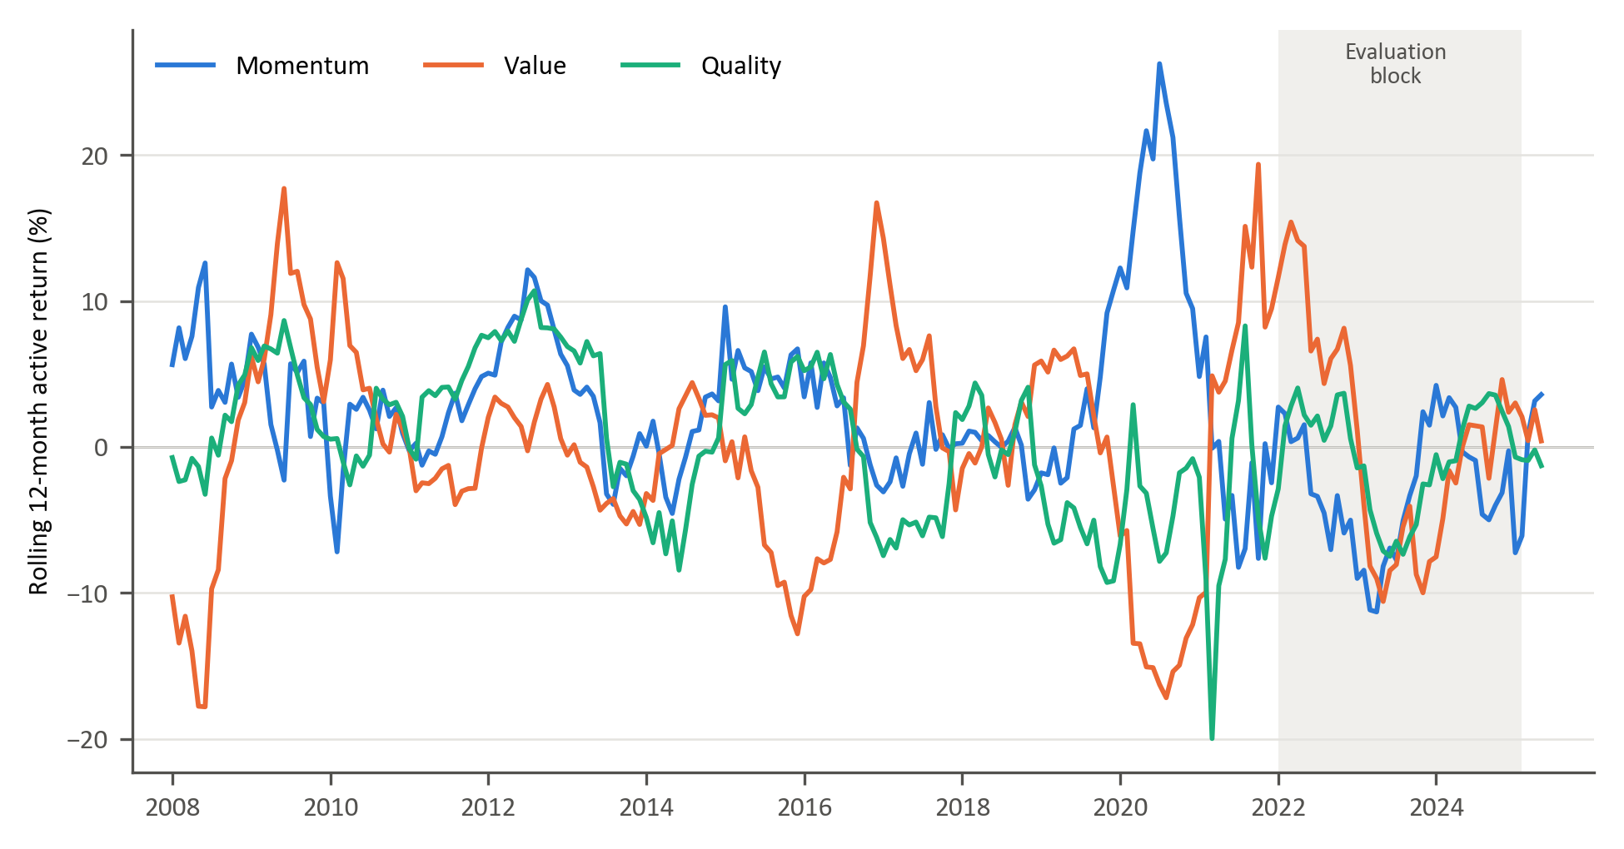
Figure 1: Rolling 12-month active returns of the momentum, value and quality factors

Figure 2 shows that these relationships are not stable. The 36-month correlation between momentum and value active returns ranges from −0.69 to 0.42, and the correlations in-volving quality range from −0.59 to 0.66 and change sign repeatedly.
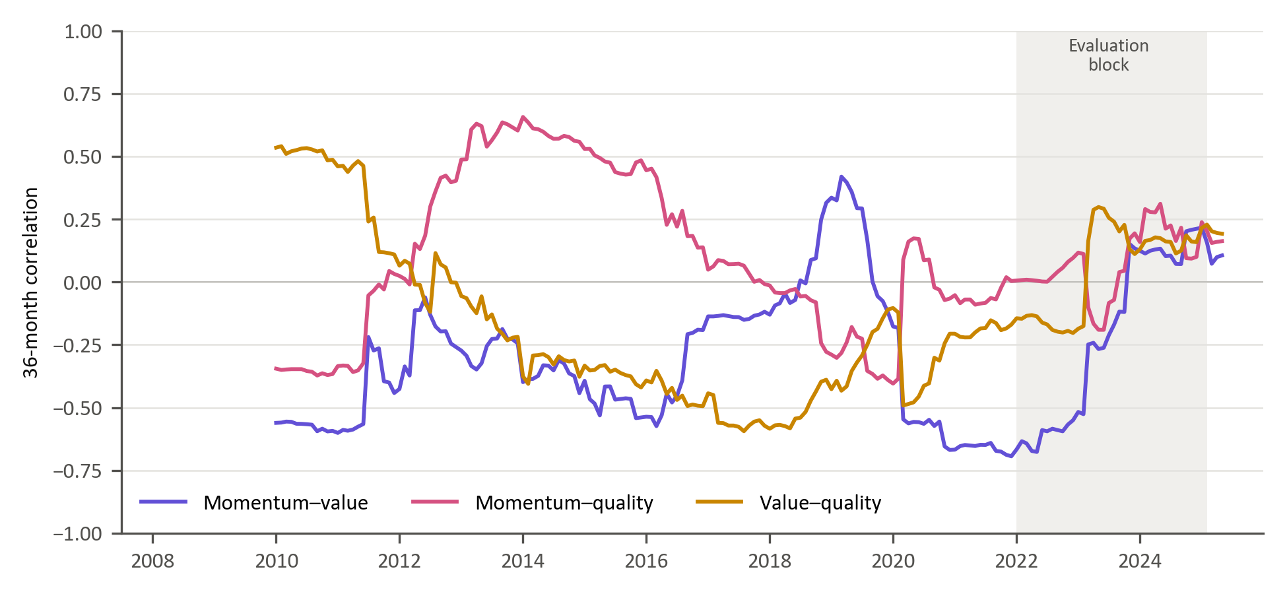
Figure 2: Rolling 36-month correlations of active returns

This time-varying correlation structure implies that absolute factor forecasting may obscure economically relevant rotation dynamics. Instead, modelling the relative performance between factor pairs directly captures style rotation. By focusing on pairwise relative returns (momentum vs value, momentum vs quality, value vs quality), the empirical framework isolates structural transitions in market leadership.
In addition to economic distinctness, modelling relative factor performance offers potential statistical advantages. Because style factors share exposure to common market-wide shocks, differencing factor returns may partially attenuate systematic noise components, isolating cross-style rotation dynamics. This relative performance based representation is conceptually aligned with long-short factor construction in asset-pricing theory and empirical evidence that relative valuation spreads and factor momentum exhibit cyclical persistence (Fama & French, 1993; Arnott, Kalesnik, & Linnainmaa, 2023) . Consequently, relative factor series may exhibit more stable regime-dependent structure than absolute factor returns, potentially enhancing predictability.
Accordingly, the pairwise timing framework adopted in this study is grounded in the economic premise that style factors represent distinct yet interacting sources of return whose relative dominance evolves over time. The objective is therefore not to forecast aggregate market returns, but to identify transitions in factor leadership within a dynamically shifting economic environment. Predicting which factor is likely to outperform can inform the direction of a tilt between styles without requiring a precise forecast of either factor’s return over the investment period. The study therefore focuses on identifying changes in relative factor leadership as an input to allocation decisions

Data sources and pre-processing

The empirical analysis uses weekly observations from March 2007 to March 2025, a total of 944 weeks. The modelling targets are derived from the weekly relative returns of three factor pairs (momentum versus value, momentum versus quality and value versus quality), computed from the factor returns defined in Section 3.2. The candidate predictors span market-based, macroeconomic and fundamental data. Section 3.6 describes how they are screened and selected, and Appendix A defines each feature.

The feature set is prepared for modelling in three steps, following established practice in empirical finance and financial machine learning (Campbell, Lo, & MacKinlay, 1997; López de Prado, 2018):
- Lagging: To limit forward information leakage, all features are lagged by four weekly observations (approximately one month) relative to the target.
- Temporal alignment: Monthly macroeconomic and fundamental series are aligned to the most recent prior weekly date and carried forward within the month.
- Imputation: Remaining gaps are forward-filled; gaps before a series’ first observation are back-filled.
The resulting feature matrix contains 929 weekly observations.

Trend-scanning target label construction
We conceptualize the challenge of generating relative factor timing signals as a binary classification task. The aim is to identify periods in which one factor outperforms or underperforms another. Reframing the forecasting task as a binary classification problem helps mitigate statistical challenges inherent in financial time-series data. In particular, financial returns are typically characterised by heavy-tailed distributions and low signal-to-noise ratios, conditions under which classification-based approaches can provide more stable predictive performance than direct return regression (Cotturo, Liu, & Proner, 2024; Dixon, Klabjan, & Bang, 2017).
To convert continuous series of relative factor returns into target variables suitable for binary classification we apply the trend scanning method introduced by Lopez de Prado (Lopez de Prado M. , 2020). Trend scanning identifies trends over the target variable by scanning forward across a range of time horizons to fit a regression line that identifies the dominant price movement. A key advantage of trend scanning is that it does not impose an arbitrary, fixed prediction horizon. A critical limitation in fixed horizons is the implicit assumption that the most significant points occur exactly at the end of the fixed interval, missing important information occurring between the set points (Lopez de Prado M. , 2020).
We start the trend-scanning procedure by transforming weekly returns into a relative return series for each factor pair. For each distinct pair of factors $i$and $j,$the weekly relative return series is defined as:
$$R_{i,j,τ}= R_{i,τ}-R_{j,τ}$$ | ( 1 )
To extract meaningful directional trends, the returns are compounded to form a cumulative relative performance series:
$${CR}_{i,j,t}= \prod_{τ≤t}{\left(1+R_{i,j,τ}\right)}$$ | ( 2 )
We then proceed to generate binary labels using the trend-scanning methodology by Lopez de Prado (Lopez de Prado M. , 2020). Unlike fixed-horizon labelling, which imposes an arbitrary prediction window, trend scanning identifies the forward-looking trend with the largest absolute slope t-statistic. For each observation date, a range of forward windows $h ∈\left[1,H\right]$ is evaluated. There is no prescriptive method to pick the maximum lookahead period. For our analysis, we set the maximum look-ahead window at H=112 week. The choice was balanced on two considerations: economic relevance, where we ensure that the window is large enough to capture meaningful price trends avoiding excessively short-term, noisy signals; and data preservation given that longer look-ahead windows reduce the sample size during model training once purging is applied to prevent look-ahead bias.
For each candidate horizon, a linear regression is estimated on the cumulative relative return series over the forward window:
$$C_{i,j,t+h}=α+ β_{h}t+ ε$$
The dominant trend is defined by the look-ahead window ${(h}_{t}^{*})$that yields the highest absolute t-statistic of the regression slope$(β_{h})$. The binary label is then assigned according to the sign of the slope at the optimal horizon:
$$Y_{i,j,t}=\left\{\begin{aligned}1, &if {\hat{β}}_{t,h_{t}^{*}}>0 \\ 0, &if {\hat{β}}_{t,h_{t}^{*}}<0 \end{aligned}\right.$$ | ( 3 )
We apply this across all factor pairs, momentum vs value, momentum vs quality, value vs quality, capturing the dominant relative factor trend at each point in time. Every observation with a resolved trend receives a binary label.
Because labels incorporate forward-looking information up to 12 weeks, overlapping information sets may arise between training and validation samples. To eliminate leakage, a purge gap of 12 weeks is imposed during cross-validation, ensuring that no training observation contains information overlapping with the validation window (Lopez de Prado M. , 2018).

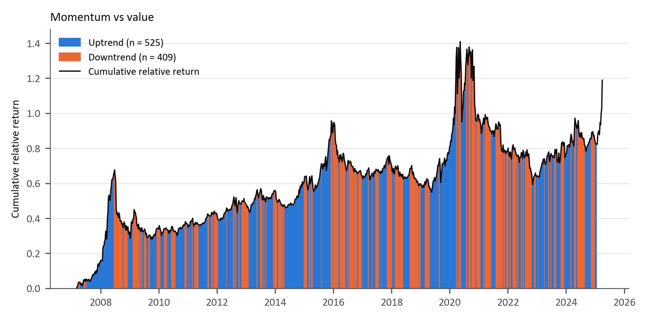
Figure 3: Trend-scanning results each factor pairs

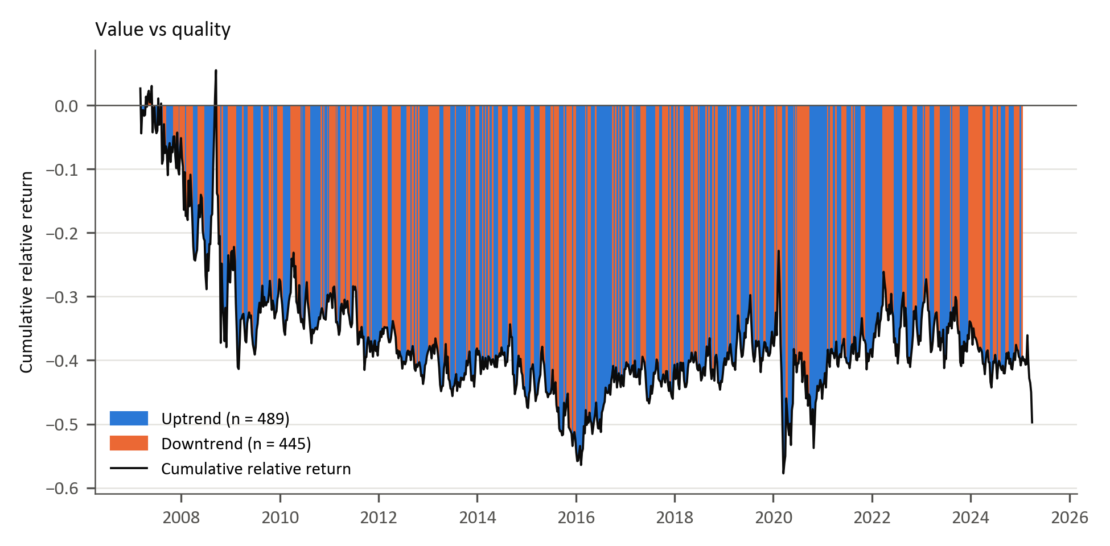
Figure 4:

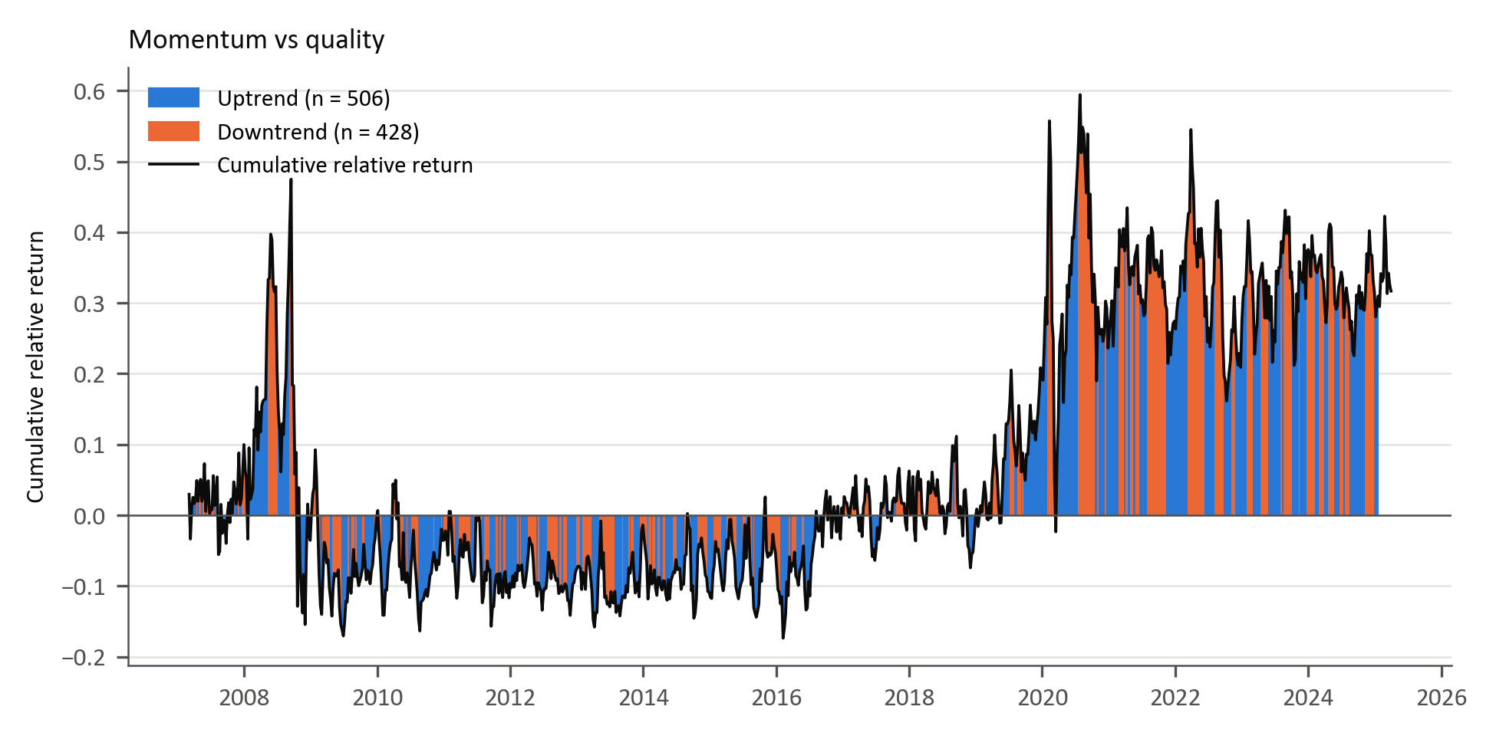
Figure 5:

Trend-scanning is applied on the rolling 12-week relative factor returns. Figures 3 to 5 plot the cumulative compounded relative return for each pair: momentum versus value (Figure 3), value versus quality (Figure 4) and momentum versus quality (Figure 5). The background shading indicates the trend label obtained from trend scanning. Uptrend (blue) and downtrend (orange) labels are assigned based on the maximum absolute t-statistic of the regression slope across candidate forward horizons. Rolling 12-month active returns of the individual factors are shown in Figure 1.

Feature selection

Section 2.1 noted that the proliferation of proposed predictors, the factor-zoo (Cochrane, 2011), raises the risk of redundant and spurious signals, and Section 2.2 that many correlated predictors make estimates unstable. The initial candidate set in this study contains 359 features in the categories summarised in Table 2, chosen on the basis of prior evidence (Gu, Kelly, & Xiu, 2020; Han, 2024; Cakici, Fieberg, Metko, & Zaremba, 2023; Feng, He, Polson, & Xu, 2023; Saetia & Yokrattanasak, 2022), with each feature defined in Appendix A. This is too many to estimate reliably from 919 labelled weekly observations per factor pair, so the set is reduced using mutual-information clustering.
The clustering is based on the mutual information (MI) between every pair of features: how much knowing one reduces uncertainty about the other, a measure that, unlike correlation, also captures nonlinear dependence (Kraskov, Stögbauer, & Grassberger, 2004; Cover & Thomas, 2006; Guyon & Elisseeff, 2003)(Kraskov, Stögbauer, & Grassberger, 2004; Cover & Thomas, 2006; Peng, Long, & Ding, 2005; Guyon & Elisseeff, 2003). Each pairwise MI value is converted to a distance, so that features carrying similar information lie close together. The features are grouped by hierarchical clustering with Ward linkage, which merges features and clusters step by step while keeping the variation within each cluster small (Ward, 1963; Hastie & Friedman, 2009). This produces compact clusters, but the number of clusters follows from where the resulting tree is cut rather than being fixed in advance.

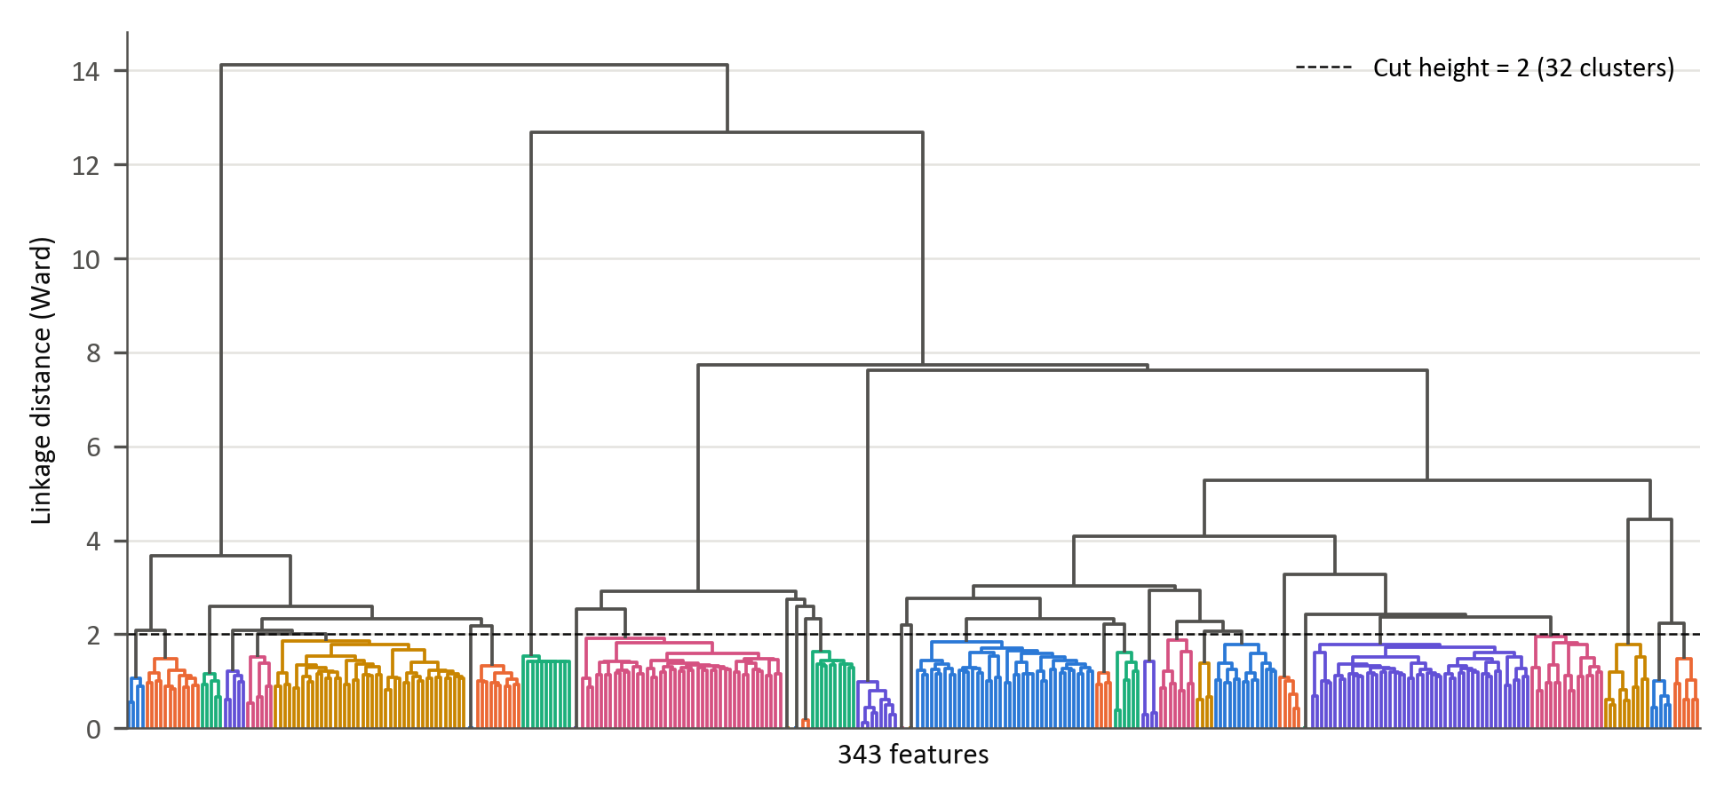
Figure 6: Hierarchical agglomeration clustering applied to the features space

Figure 6 represents the entire feature space. The maximum distance for clusters selection is set at 2 (as shown by the horizontal dotted line), resulting in a total of 32 clusters. Within each cluster, the feature exhibiting the lowest average distance to other members is retained. This criterion identifies the most informationally central variable within each group. Importantly, this selection is unsupervised and does not rely on predictive performance relative to the target variable. As a result, feature reduction is conducted independently of the classification task, avoiding look-ahead bias and preventing inadvertent target leakage.
In addition to this clustered set, a further 18 relative-factor features were included by design. These variables capture pairwise relative performance, co-movement, and relative volatility dynamics that are directly aligned with the study’s factor-timing objective and were therefore treated as structurally relevant inputs rather than candidates for redundancy pruning. The final modelling matrix therefore consists of 50 predictors: 32 representative features selected via mutual-information clustering plus 18 relative-factor features retained on theoretical grounds.
Table 1: Summary of the 50 modelling features by category

Feature category | Features | Examples | Economic rationale | Evidence
Price-based volatility | 9 | Volatility term-structure components; USDZAR and EURUSD implied volatility; global bond and property volatility; gold price measures | Uncertainty and risk-on/risk-off conditions | (Gu, Kelly, & Xiu, 2020); (Daniel & Moskowitz, Momentum crashes, 2016)
Fundamental valuation | 6 | JSE and MSCI World fundamental components; TOP40 price-to-book and price-to-EBITDA; JSE price-to-sales; MSCI World price-to-earnings | Valuation spreads and expected mean reversion | (Cakici, Fieberg, Metko, & Zaremba, 2023)
Sentiment and risk appetite | 8 | US consumer confidence; commodity index component; gold structural-break, complexity, skewness and kurtosis measures; global equity trend and entropy | Investor risk appetite and shifts in uncertainty | (Saetia & Yokrattanasak, 2022)
Macroeconomic | 9 | SA and US yield-curve curvature; SA yield-curve slope; SA CDS slope; rand PPP valuation; energy prices; USDZAR forward pricing and entropy | Growth expectations, policy stance and sovereign risk | (Fang, Chen, & Ren, 2022)
Factor relative performance | 12 | 1- and 3-month relative momentum,  12-week correlation and standardised 12-week relative return, each for the three pairs | Persistence and rotation in style leadership | Gu et al. (2020); Daniel & Moskowitz (2016)
Factor relative volatility | 6 | 12-week relative volatility and volatility ratio, each for the three pairs | Instability in relative performance | Gu et al. (2020); Daniel & Moskowitz (2016)
Note: Appendix A defines each feature, and Table B.8 in Appendix B lists every feature with its rationale and supporting evidence.

Model training

The objective function
All three models aim to classify whether the first-named factor in each pair is expected to outperform the second, based on prevailing market and economic conditions. Each model estimates the conditional probability of relative factor outperformance defined as:
$$P(y_{t}=1|X_{t})$$ | ( 4 )
This is achieved by producing a probability score between zero and one:
$${\hat{p}}_{t}∈[0,1]$$ | ( 5 )
A factor timing signal is generated when the probability is at least a threshold, τ, fixed at 0.5 for all models and factor pairsτ:
$${\hat{y}}_{t}=1\{{\hat{p}}_{t}≥τ\}$$ | ( 6 )

Logistic regression
The simplicity and direct interpretability of linear models have contributed to their significance in finance. Logistic regression provides a transparent economic interpretation of how each predictor influences the likelihood of factor outperformance. The model assumes a linear relationship between the log-odds of the outcome and the predictor variables (Hosmer, Lemeshow, & Sturdivant, 2013; James, Witten, Hastie, & Tibshirani, 2021). The model assumes the assumes that the log-odds of a binary outcome are a linear function of the predictor:
$$logit\left(P\left(y_{t} | X_{t}\right)\right)=\ln\left(\frac{P\left(y_{t} | X_{t}\right)}{1-P\left(y_{t} | X_{t}\right)}\right)= β_{0}+X_{t}^{T}β$$ | ( 7 )
Here, $β_{0}$ is the intercept term and $β∈R^{p}$ is a vector of coefficients measuring linear impact of each feature on the log-odds. To obtain a predicted probability from the linear predictor, the inverse of the logit, known as the logistic (sigmoid) function, is used:
$${\hat{p}}_{t}=σ\left(β_{0}+X_{t}^{T}β\right)= \frac{1}{1+e^{-(β_{0}+X_{t}^{T}β)}}$$ | ( 8 )

Model parameters $\left(β_{0}, β\right)$are estimated by minimizing the penalized log-likelihood function.
$$L(β)=\sum_{t∈D_{train}}{w_{t}}\left[-y_{t}\log{{\hat{p}}_{t}}-\left(1-y_{t}\right)\log{(1-{\hat{p}}_{t})}\right]+ λ\left(α∥β∥_{1}+\frac{1-α}{2}∥β∥_{2}^{2}\right)$$ | ( 9 )
where $λ≥0$ controls overall regularization strength and $α∈[0,1]$, sets the mix of LASSO L1 and ridge L2 penalties. This elastic-net penalty, common in financial applications, limits overfitting, mitigates multicollinearity and stabilises the estimates (Zou & Hastie, 2005; Tibshirina, 1996; Gu, Kelly, & Xiu, 2020).
The model is fitted with the elastic-net logistic regression of the scikit-learn Python library (Pedregosa et al., 2011), which minimises Equation (9) with unit observation weights, C = 1/λ and l1_ratio = α, without penalising the intercept. Coefficients are estimated with the saga solver, which supports the elastic-net penalty (Defazio, Bach, & Lacoste-Julien, 2014), and every fit converged within the iteration limit. Predictors are standardised with a scal-er fitted on the training window only. The solver settings and the grid for α and λ are giv-en in Table 4.

Generalized additive models (GAMs)
Generalized Additive Models (GAMs) introduced by (Hastie & Tibshirani, 1986) extend generalised linear models by introducing nonlinear transformations of the original predictors as new additive terms in an otherwise linear model. This model enables nonlinearity while maintaining transparency. The GAM specification for binary classifications structurally resembles that of the logistic regression. Using the logit transformation, the conditional probability of outperformance is given by:
$$g\left(P\left(y_{t}=1|X_{t}\right)\right)= β_{0}+\sum_{i=1}^{p}{s_{i}(X_{t,i})}$$ | ( 10)
$β_{0}$ is the intercept term and each $s_{i}(.)$ is a smooth, potentially nonlinear function capturing the marginal effect of predictor $(X_{t,i})$ (Hastie & Tibshirani, 1986). The predicted probability for classification is given by:
$${\hat{p}}_{t}=σ\left(β_{0}+ \sum_{i=1}^{p}{s_{i}\left(x_{t,i}\right)}\right)$$ | (11)
Each smooth $s_{i}(.)$ is represented via a basis expansion: $s_{i}\left(x\right)=B_{i}{(x)}^{T}θ_{i}, B_{i}\left(x\right)∈R^{k_{i}}$,
$B_{i}\left(x\right)$ is a vector of spline basis function, which control the functional relationship between a predictor variable and a conditional response, whose coefficients $\left\{θ_{i}\right\}$ must be estimated. The size of the basis expansion limits the smoothing spline’s potential complexity with a larger set of basis functions allowing greater flexibility. We use cubic splines with $k_{i}$ basis functions per smooth term. Given that each spline $s_{i}(.)$ can be visualised independently, spline bases enable GAMs to model nonlinearity while maintaining additive interpretability (James, Witten, Hastie, & Tibshirani, 2021). The number of basis functions is common to all smooth terms and is selected from {4, 5, 7, 10} (Table 4).
We estimate the coefficients $\left\{θ_{i}\right\}$ and $β_{0}$ by minimizing:
$$L\left(S\right)=\sum_{t∈D_{train}}{w_{t}\left[{-y}_{t}\log{{\hat{ p}}_{t}}-\left(1-y_{t}\right)\log{(1-{\hat{p}}_{t})}\right]}+ \sum_{i=1}^{p}{λ_{i}θ_{i}^{T}S_{i}θ_{i}}$$ | (12)

The smoothness of the spline is controlled by a smoothing penalty $(λ_{i})$ and ${(S}_{i})$ is the spline penalty matrix (Hastie & Tibshirani, 1986). We use the Pygam library from python to implement this GAM model. In the implementation, a single smoothing penalty λ is applied to all smooth terms and selected by cross-validation, and predictors are standardised within each training window, as for logistic regression.

Extreme gradient boost (XGBoost)
Tree-based ML models are non-parametric and use logic that departs markedly from traditional econometric models to capture nonlinearities within the data. These models build on the concept of decision trees, where binary groups are created by grouping observations with similar characteristic. They use a hierarchical tree structure that partitions the predictor space by recursively selecting features and splits that maximize a set improvement criterion such as information gain, entropy reduction, Gini reduction, or variance reduction depending on the task (Breiman, Friedman, Olshen, & Stone, 1984; Hastie & Friedman, 2009). This process ensures that the most informative features for predicting the target are placed higher in the tree structure.
Although decision trees are intuitive, single classification and regression trees (CART) easily overfit (Hastie & Friedman, 2009; Breiman, Friedman, Olshen, & Stone, 1984; Gu, Kelly, & Xiu, 2020). Ensemble methods like bagging and boosting address this shortcoming by combining multiple weak learners (Friedman, 2001; Breiman L. , 1996). This study uses boosting, in which the weak learners are added sequentially. XGBoost constructs an additive model of the form:

$$F_{M}\left(X_{t}\right)=\sum_{m=1}^{M}{f_{m}\left(X_{t}\right), } f_{m}∈F$$ | (13)
where each $f_{m}$ is a single CART (Chen & Guestrin, 2016). For binary classification, the ensemble output is mapped to probabilities using the logistic sigmoid function given by:
$${\hat{p}}_{t}= σ\left(F_{M}\left(X_{t}\right)\right), σ\left(x\right)= \frac{1}{(1+e^{-x})}$$ | (14)

At each boosting iteration $(m)$, we aim to minimize:
$$L^{(m)}=\sum_{t∈D_{train}}{w_{t}}l\left(y_{t},{\hat{p}}_{t}^{\left(m-1\right)}+f_{m}\left(X_{t}\right)\right)+Ω\left(f_{m}\right)$$ | (15)
Where the logistic loss function defined as:
$$l\left(y,p\right)=-y\log{p}-\left(1-y\right)\log{(1-p)}$$ | (16)
and tree regularization function given by:
$$Ω\left(f\right)=γT+\frac{λ}{2}\sum_{j=1}^{T}{w_{j}^{2}}$$ | (17)
$(T)$ is the number of leaves and ${(w}_{j})$ the leaf weight. Each tree is trained to fit the residuals of the previous iteration, allowing the ensemble to progressively correct its errors. In this study, the XGBoost model is trained using the xgboost Python library with 500 boosting rounds and the binary logistic objective. Because tree splits are unaffected by monotonic transformations, predictors are not standardised for XGBoost. This implementation executes the theoretical additive tree-boosting framework described (Chen & Guestrin, 2016).

Table 2 Model comparison
Model | Model Complexity | Interpretability | Strengths | Limitations / Risks | Key Hyperparameters | References
Logistic Regression | Low | High | Transparent coefficients (economic interpretability); | Misses nonlinearities; | Maximum iterations (max_iter); | (Hosmer, Lemeshow, & Sturdivant, 2013);  (Zou & Hastie, 2005)
Logistic Regression | Low | High | Efficient with small samples; | Sensitive to multicollinearity; | Regularization strength (λ);
Logistic Regression | Low | High | Robust to noise with regularization | Limited predictive power in complex regimes | L1/L2 mixing ratio (α);
Logistic Regression | Low | High |  |  | Solver tolerance (tol)
GAM | Moderate | Moderate–High | Captures smooth nonlinear effects; | Cannot easily model interactions; | Number of splines (n_splines); | (Hastie & Tibshirani, 1986);  GAM formulation  (Wood, 2017);  (Gu, Kelly, & Xiu, 2020)
GAM | Moderate | Moderate–High | Retains partial interpretability; | Computationally heavier; | Smoothness penalty (λ_i);
GAM | Moderate | Moderate–High | Controls overfitting via smoothing penalty | Requires careful selection of smoothing parameters | Maximum iterations (max_iter)
XGBoost | High | Low | Captures high-order nonlinearities and interactions; | Reduced interpretability; | Learning rate (η); | (Friedman, 2001);  (Chen & Guestrin, 2016);  (Krauss, Do, & Huck, 2017)
 |  |  |  |  | Maximum tree depth (max_depth);
XGBoost | High | Low | Inherent feature selection via splits | Prone to overfitting without tuning; | Subsample ratio (subsample);
 |  |  |  | Sensitive to hyperparameter configuration | Number of boosting rounds (n_estimators);
 |  |  |  |  | Regularization (λ, γ)

Hyperparameter tuning and model validation
Robust evaluation of predictive performance in financial time series requires validation procedures that explicitly account for temporal dependence, non-stationarity, and overlapping information sets (Campbell, Lo, & MacKinlay, 1997; Gu, Kelly, & Xiu, 2020). Conventional k-fold cross-validation assumes independent and identically distributed observations and therefore risks severe information leakage when applied to time-ordered financial data (Bergmeir & Benítez, 2012; Lopez de Prado M. , 2018). To address these challenges, model tuning and evaluation are implemented using a two-stage validation architecture. Firstly, CPCV is used exclusively for hyperparameter optimization within the training windows (Lopez de Prado M. , 2018; Lopez de Prado M. , 2020). Then, the optimised parameter set is used in the walk-forward validation to assess out-of-sample predictive performance.

Combinatorial cross-purged validation
The choice of hyperparameters controls the model’s complexity, limiting the potential for overfitting. CPCV generates multiple unique combinations of training and validation splits, ensuring that each split is used for validation the same number of times. The combinatorial equation is used to calculate the exact number of training/validation combinations required to construct a set of back-testing paths. A back-testing path chronologically orders the validation predictions from the different CPCV combinations to form one continuous out-of-sample time series. In our case, the number of validation splits and the total number of splits are given by
k=2 and N=5 (N-k) respectively.k=1N=5
The number of distinct training-validation combinations is given by the binomial coefficient:
CN,k= Nk | (18)
ϕN,k=kNNN-k
ϕ5,1=1The number of back-test paths that can be constructed from these combinations is:
ϕN,k=kNNN-k | (19)
In our case, k=2 and N=5, resulting in C5,2=10 training-validation combinations and ϕ5,2=4 back-test path. Hyperparameters are selected on the mean ROC-AUC of the ten combinations, each computed from the predictions of a single fitted model.
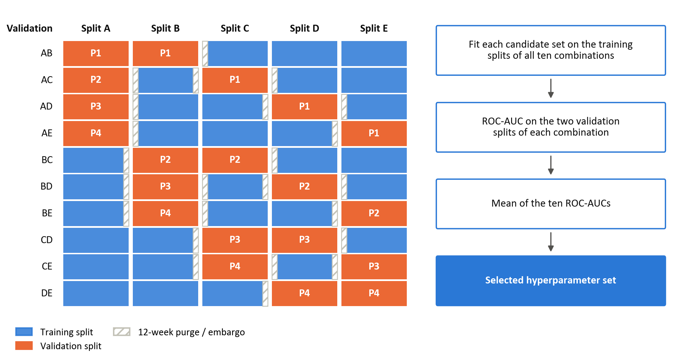
Figure 7: CPCV back-test path, k=1 validation set, N=5 cross validation splits

In Figure 7, each row is one combination: the orange blocks are its two validation splits, the blue blocks its training splits, and the hatched strips the 12-week purge and embargo around each validation split. The label on each validation split gives the back-test path (P1 to P4) to which its predictions are assigned.
To ensure that the validation set performance is still a good proxy for the performance on unseen data, samples in the validation set need to be reasonably independent from those in the training set. (Lopez de Prado M. , 2018) addresses this by remove any training data whose information horizon overlaps with the validation set (i.e. purging). A 12-week purge before each validation split and a 12-week embargo after it exceed the ten-week label horizon (Section 3.5). A candidate set that cannot be fitted on all ten combinations is excluded (Appendix C). The initial search uses the 763 observations before the evaluation block, with predictors standardised on the whole sample and no purge at its boundary, so the labels of its last ten observations may draw on the first weeks of the evaluation block. Later searches use the purged training window then available (Section 3.8.2).

Table 3: Key hyperparameters
Model | Parameter combinations | Key hyperparameters | Tuning parameter grid
Logistic | 18 | L1/L2 mixing ratio (α) | [ 0 , 0.5 , 1 ]
Logistic | 18 | Regularisation strength (λ) | [ 0.01 , 0.1 , 1 , 10 , 100 , 1000 ]
Logistic | 18 | Solver | saga (fixed)
Logistic | 18 | Maximum iterations | 100,000 (fixed)
Logistic | 18 | Convergence tolerance | 10⁻⁶ (fixed)
GAM | 20 | Number of splines | [ 4 , 5 , 7 , 10 ]
GAM | 20 | Smoothness penalty (λ) | [1, 10, 100, 1000, 10000]
GAM | 20 | Spline order | 3, cubic (fixed)
GAM | 20 | Maximum iterations | 1000 (fixed)
XGBoost | 216 | Learning rate (η) | [ 0.01 , 0.03 , 0.1 ]
XGBoost | 216 | Maximum tree depth | [ 2 , 3 , 4 ]
XGBoost | 216 | Minimum child weight | [ 5 , 10 , 20 ]
XGBoost | 216 | L2 regularisation (λ) | [ 1 , 10 , 100 , 1000 ]
XGBoost | 216 | Subsample ratio | [ 0.6 , 0.8 ]
Note: grids are searched exhaustively. XGBoost uses 500 boosting rounds, the binary logistic objective and a fixed random seed in every configuration.

Walk-forward validation
While CPCV reduces overlap between training and validation labels during hyperparame-ter selection, it does not fully replicate real-time deployment. Final performance is there-fore assessed using an expanding-window walk-forward framework. Walk-forward valida-tion repeatedly trains a model on past data and evaluates it on the observations that follow, which limits leakage and gives a more realistic assessment of forecasting ability.

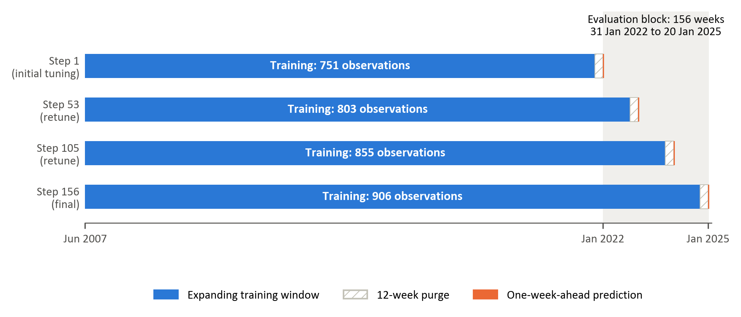
Figure 8: Expanding-window walk-forward validation with a 12-week purge and retuning every 52 predictions.
At each iteration, models are trained on an expanding window containing every labelled observation up to 12 weeks before the prediction date, and then predict the forward trend label at the next evaluation date. The training window grows from 751 observations at the first prediction to 906 at the last. Hyperparameters are re-optimised every 52 predictions, balancing adaptation to structural changes in market conditions against sensitivity to transient fluctuations. They are therefore selected three times, before the first prediction and after the 52nd and 104th predictions, producing 156 weekly forecasts of variable-horizon trend labels from 31 January 2022 to 20 January 2025.

Performance evaluation
Model performance is evaluated along three complementary dimensions, directional accuracy, ranking ability and probability quality, supplemented by confusion-matrix analysis of classification errors. These measures capture distinct aspects of classification quality and jointly provide a comprehensive assessment of predictive performance. Because the objective of the study is to identify transitions in relative factor leadership rather than forecast return magnitudes, classification-based metrics are appropriate. In financial settings characterised by heavy tails, regime shifts, and low signal-to-noise ratios, reliance on a single performance measure can be misleading. A multi-metric framework therefore improves robustness and interpretability (Dixon, Klabjan, & Bang, 2017; James, Witten, Hastie, & Tibshirani, 2021).

Directional accuracy, the proportion of correct classifications, reflects whether the model correctly identifies the leading factor within each pair (James, Witten, Hastie, & Tibshirani, 2021). While intuitive and directly interpretable from an allocation perspective, accuracy alone does not account for prediction confidence or ranking quality Accuracy is complemented by the confusion matrix, which cross-tabulates predicted and realised classes into true negatives (TN), false positives (FP), false negatives (FN) and true positives (TP) at the 0.5 threshold (Fawcett, 2006). The matrix shows whether errors are concentrated in one class. This matters here because a model that assigns most observations to one class can attain respectable accuracy while having little ability to identify the other. The share of observations predicted positive is therefore compared with the realised positive share, and confusion matrices are reported for every model and factor pair in Chapter 4.

To assess discrimination ability independently of any fixed decision threshold, the Receiver Operating Characteristic (ROC) curve is employed. The ROC curve evaluates the model’s capacity to assign higher predicted probabilities to periods of genuine outperformance than to underperformance periods. The Area Under the ROC Curve (ROC-AUC) summarises this discriminatory power on a scale between zero and one, where 0.5 corresponds to random classification (James, Witten, Hastie, & Tibshirani, 2021; Fawcett, 2006). Because it is also robust to moderate class imbalance, ROC-AUC is the selection criterion in the CPCV search (Section 3.8.1).

In addition to classification correctness and ranking ability, the quality of predicted probabilities is evaluated using log-loss. Log-loss penalises confident but incorrect predictions more heavily than uncertain misclassifications, thereby assessing overall probability quality rather than only the binary decision (Good, 1952; Gneiting & Raftery, 2007). (Bishop, 2006; Murphy, 1973). Since the modelling framework produces probabilistic forecasts of relative factor outperformance, calibration quality is economically meaningful. Well-calibrated probabilities allow for flexible allocation rules, such as probability-weighted exposure adjustments, rather than simple binary switching between styles (Gneiting & Raftery, 2007; Dixon, Klabjan, & Bang, 2017; López de Prado, 2018).

Improvements across all three measures provide stronger evidence of genuine predictive structure than improvements in any single metric alone. Nevertheless, statistical performance does not automatically imply economic profitability. A further translation of predictive signals into portfolio outcomes can be evaluated separately through risk-adjusted performance analysis, which falls outside the scope of this study. Because the evaluation block contains only 156 weekly observations and the labels are persistent, small differences in these point estimates are interpreted with caution.

Feature importance

The feature-importance analysis examines which predictors drive each model’s forecasts, whether the leading predictors belong to the economically motivated categories of Table 2, and whether the three models, and the three factor pairs, rely on the same information. Importance is measured with Shapley values from cooperative game theory (Shapley, 1953), as implemented in the SHAP framework (Lundberg, et al., 2020; Lundberg & Lee, 2017).
Shapley values decompose each prediction into additive contributions from the features, relative to the model’s average prediction. A feature’s contribution is its marginal effect on the prediction, averaged over all combinations of the other features, so nonlinear and interaction effects are attributed to the features involved (Štrumbelj & Kononenko, 2010). Unlike split gain in tree models or the size of a regression coefficient, the measure is defined in the same way for every model (Joseph, 2019; Joseph, 2024).
The values are computed in log-odds space, the scale on which all three models produce their score before the logistic link is applied. They are computed once for each model and factor pair, for a model refitted with the initially selected hyperparameters on the 763 ob-servations of the initial tuning sample (Section 3.8.1), and every observation of that sam-ple is explained; the values therefore describe these refits rather than the 156 walk-forward models. For logistic regression they are exact: each contribution is the coefficient multiplied by the deviation of the standardised feature from its sample mean. For XGBoost, exact tree Shapley values are obtained with TreeSHAP (Lundberg et al., 2020). For the GAM, which has no specialised explainer, they are permutation estimates against 100 background observations drawn from the training sample, and so carry some approx-imation error (Štrumbelj & Kononenko, 2010).
A feature’s global importance is its mean absolute Shapley value over the explained sam-ple: the average size of its contribution, regardless of direction. For each model and factor pair, the ten features with the largest global importance are reported, coloured by their category in Table 2. Because the explainers and the spread of the attributions differ be-tween model classes, the models are compared by the ranking of their features rather than by the size of the values, and a feature that ranks highly in several models is treated as stronger evidence than one that leads a single model.

The attributions describe how the fitted models use the features, not causal effects, and a high ranking does not show that a feature carries stable out-of-sample information (Ku-mar et al., 2020; Molnar, 2022). Correlated features can share or exchange attribution, so closely related features, such as the two rand implied-volatility measures, are read to-gether rather than as separate signals. For these reasons the rankings are interpreted as exploratory.

Results

Overview of the Evaluation Framework
This chapter presents the final out-of-sample results for the prediction of relative leadership among the momentum, value and quality factors in the South African equity market. Three model classes are evaluated: regularised logistic regression, a generalised additive model (GAM), and extreme gradient boosting (XGBoost). These models provide a progression from a linear specification, through additive nonlinear effects, to a flexible tree-based model capable of representing nonlinearities and interactions.
Hyperparameters are selected using combinatorial purged cross-validation (CPCV) with five chronologically ordered groups and two groups held out in each combination (Lopez de Prado M. , 2020). This produces ten training-validation combinations and four back-test paths. A 12-week purge before, and a 12-week embargo after, each held-out CPCV group addresses the overlapping information horizon introduced by the trend-scanning labels (Lopez de Prado M. , 2018; Lopez de Prado M. , 2020). Final performance is evaluated using a separate expanding walk-forward procedure with a 12-week pre-test purge (Bergmeir & Benítez, 2012; Tashman, 2000). Each model is initially trained on 751 observations, with the training sample expanding to 906 observations by the end of the evaluation period. Hyperparameters are retuned every 52 predictions.
The final evaluation block contains 156 weekly observations from 31 January 2022 to 20 January 2025. The positive class indicates leadership by the first-named factor (i.e., a positive momentum-versus-value observation indicates that the trend-scanning label favours momentum over value.)
Performance is assessed using accuracy, ROC-AUC and log-loss. Accuracy reports the proportion of correct classifications, ROC-AUC measures ranking ability (Fawcett, 2006; Hanley & McNeil, 1982), and log-loss evaluates the quality of the predicted probabilities. Classification errors are examined through consolidated confusion-matrix counts.

Out-of-Sample predictive performance
Table 4.2 presents a compact comparison of classification accuracy, ranking ability and probability quality. No single model dominates every factor pair and performance dimension. The largest ROC-AUC in the study is 0.589, indicating that the final predictive relationships are modest rather than strongly discriminative (Hosmer, Lemeshow, & Sturdivant, 2013; Israel, Kelly, & Moskowitz, 2020).

Factor pair | Model | Accuracy | ROC-AUC | Log-loss
Momentum vs value | Logistic | 48.1% | 55.1% | 0.688
 | GAM | 59.0% | 58.2% | 1.609
 | XGBoost | 61.5% | 58.9% | 0.759
Momentum vs quality | Logistic | 51.3% | 55.0% | 0.687
 | GAM | 48.1% | 55.7% | 0.932
 | XGBoost | 55.1% | 57.8% | 0.719
Value vs quality | Logistic | 56.4% | 58.5% | 0.684
 | GAM | 51.9% | 52.1% | 1.097
 | XGBoost | 48.7% | 56.5% | 0.691

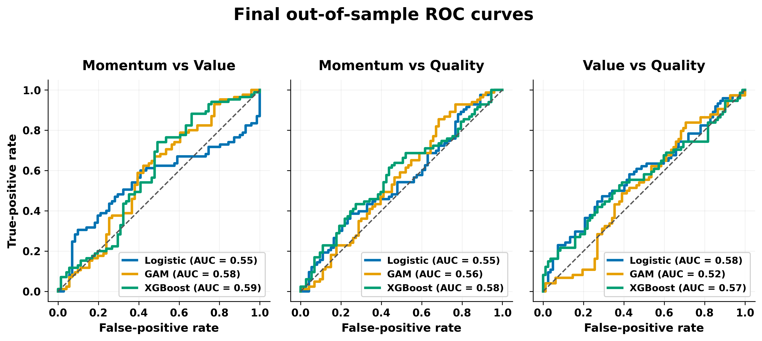

Momentum versus Value
Momentum versus Value provides the strongest classification result in the study. XGBoost achieves the highest accuracy (61.5%) and ROC-AUC (0.589) for this pair. The GAM ranks second, with accuracy of 59.0% and ROC-AUC of 0.582. The point estimates therefore indicate that nonlinear structure contributes to this factor pair. The point estimates therefore indicate that nonlinear structure contributes to this factor pair, consistent with evidence that tree-based models improve style rotation on the JSE (Page, McClelland, & Auret, 2024). The size of the effect remains moderate because the best AUC is below 0.60. While results support a relative advantage for XGBoost within this pair, they do not indicate strong separation between momentum and value leadership regimes. Logistic regression performs poorly at the fixed threshold, with accuracy of 48.1% and ROC-AUC of 0.551. Its comparatively low log-loss of 0.688 indicates more conservative probabilities, as expected when regularisation shrinks coefficients towards zero (Hastie & Tibshirani, 1986).

Momentum versus quality
Predictive performance is weaker for momentum versus quality. XGBoost again produces the strongest overall classification results, with accuracy of 55.1% and ROC-AUC of 0.578. These values indicate only modest separation between the two classes. Logistic regression records the lowest log-loss, at 0.687, but its accuracy is only 51.3%. The confusion matrix shows that it predicts the positive class frequently, so its relatively strong detection of momentum-leadership observations does not represent consistent discrimination between both regimes. The GAM displays the opposite error pattern. Its ROC-AUC of 0.557 suggests limited ranking information, but it predicts the positive class infrequently. Its accuracy of 48.1% remains consistent with chance-like classification.

Value versus quality
Value versus quality reverses the ordering observed in the momentum pairs. Logistic regression is the strongest model, with accuracy of 56.4%, ROC-AUC of 0.585 and log-loss of 0.684. It is the only model for this pair to combine accuracy above 55% with log-loss below the uninformative 0.693 reference value. XGBoost produces a ROC-AUC of 0.565, suggesting some ranking information, but its accuracy of 48.7% and log-loss of 0.691 do not indicate a corresponding advantage in classification or probability quality. It therefore ranks below logistic regression on all three reported measures and below the GAM on accuracy. The GAM is close to chance across the reported measures, with accuracy of 51.9% and ROC-AUC of 0.521. The evidence for predictable value-versus-quality factor pair is therefore concentrated in the linear specification rather than in the more flexible models.

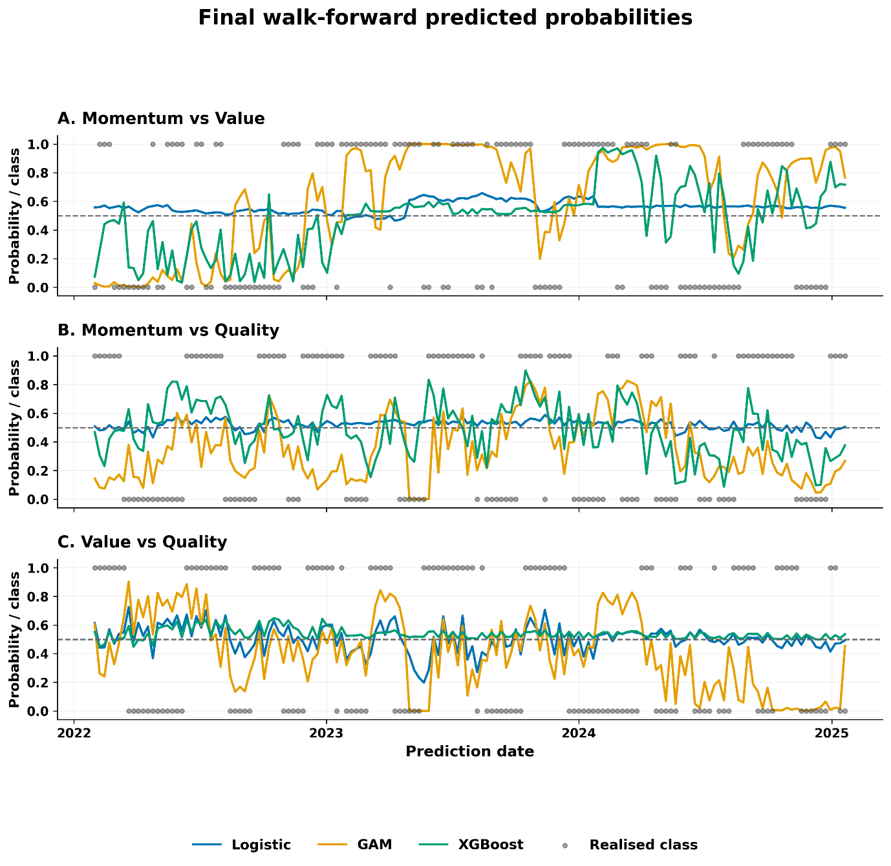

Consolidated confusion-matrix analysis and probability quality
Table 4.1 reports the realised class distribution in the common 156-week evaluation block. The three targets are reasonably balanced, although momentum leadership is slightly more common in the two momentum pairs. These counts provide the context required to interpret the confusion matrices reported below.

Factor pair | Negative observations | Positive observations | Positive share
Momentum vs value | 71 | 85 | 54.5%
Momentum vs quality | 73 | 83 | 53.2%
Value vs quality | 82 | 74 | 47.4%

Table 4.4 reports the confusion-matrix counts and predicted-positive shares. These diagnostics explain several apparent inconsistencies between ROC-AUC and accuracy.
Table 4.4. Confusion-matrix diagnostics at the 0.5 threshold
Factor pair | Model | TN | FP | FN | TP | Predicted positive | Actual positive
Momentum vs value | Logistic | 1 | 70 | 11 | 74 | 92.3% | 54.5%
 | GAM | 32 | 39 | 25 | 60 | 63.5% | 54.5%
 | XGBoost | 37 | 34 | 26 | 59 | 59.6% | 54.5%
Momentum vs quality | Logistic | 17 | 56 | 20 | 63 | 76.3% | 53.2%
 | GAM | 52 | 21 | 60 | 23 | 28.2% | 53.2%
 | XGBoost | 43 | 30 | 40 | 43 | 46.8% | 53.2%
Value vs quality | Logistic | 44 | 38 | 30 | 44 | 52.6% | 47.4%
 | GAM | 53 | 29 | 46 | 28 | 36.5% | 47.4%
 | XGBoost | 6 | 76 | 4 | 70 | 93.6% | 47.4%

XGBoost provides the most balanced class treatment for the two momentum pairs. For momentum versus value, it predicts the positive class in 59.6% of observations compared with an actual rate of 54.5%. For momentum versus quality, its positive prediction share is 46.8% compared with an actual rate of 53.2%. Logistic regression is most balanced for value versus quality, where its positive prediction rate is 52.6% compared with the actual rate of 47.4%.
The extreme positive-class tendencies of logistic regression for momentum versus value and XGBoost for value versus quality produce high positive-class detection rates but poor specificity.
The probability results introduce a further trade-off. An uninformative forecast of 0.5 for every observation has a log-loss of approximately 0.693. Logistic regression records log-loss between 0.684 and 0.688 for all three pairs, representing only a small improvement but avoiding severe overconfidence. The GAM produces log-loss between 0.932 and 1.609, indicating that some incorrect forecasts receive excessive probability. XGBoost has stronger average ranking and thresholded performance, but its log-loss exceeds 0.693 for both momentum pairs. Thus, better discrimination does not necessarily imply better probability quality.

Feature Importance

Global feature importance is measured using the mean absolute SHAP value from the saved model explanations. The values indicate which inputs exerted the greatest influence on each fitted model. They do not establish causal relationships or demonstrate that the variables contain stable out-of-sample information (Kumar et al., 2020; Molnar, 2022). This distinction is important because all final ROC-AUC values remain below 0.60. Rankings are compared more cautiously than raw SHAP magnitudes because the scale and distribution of attributions differ across model classes. Across Figures 4.3–4.5, bar colour identifies the feature classification group defined in Table 1 of Section 3.6, enabling the economic composition of each model's leading predictors to be compared directly.

Momentum versus value
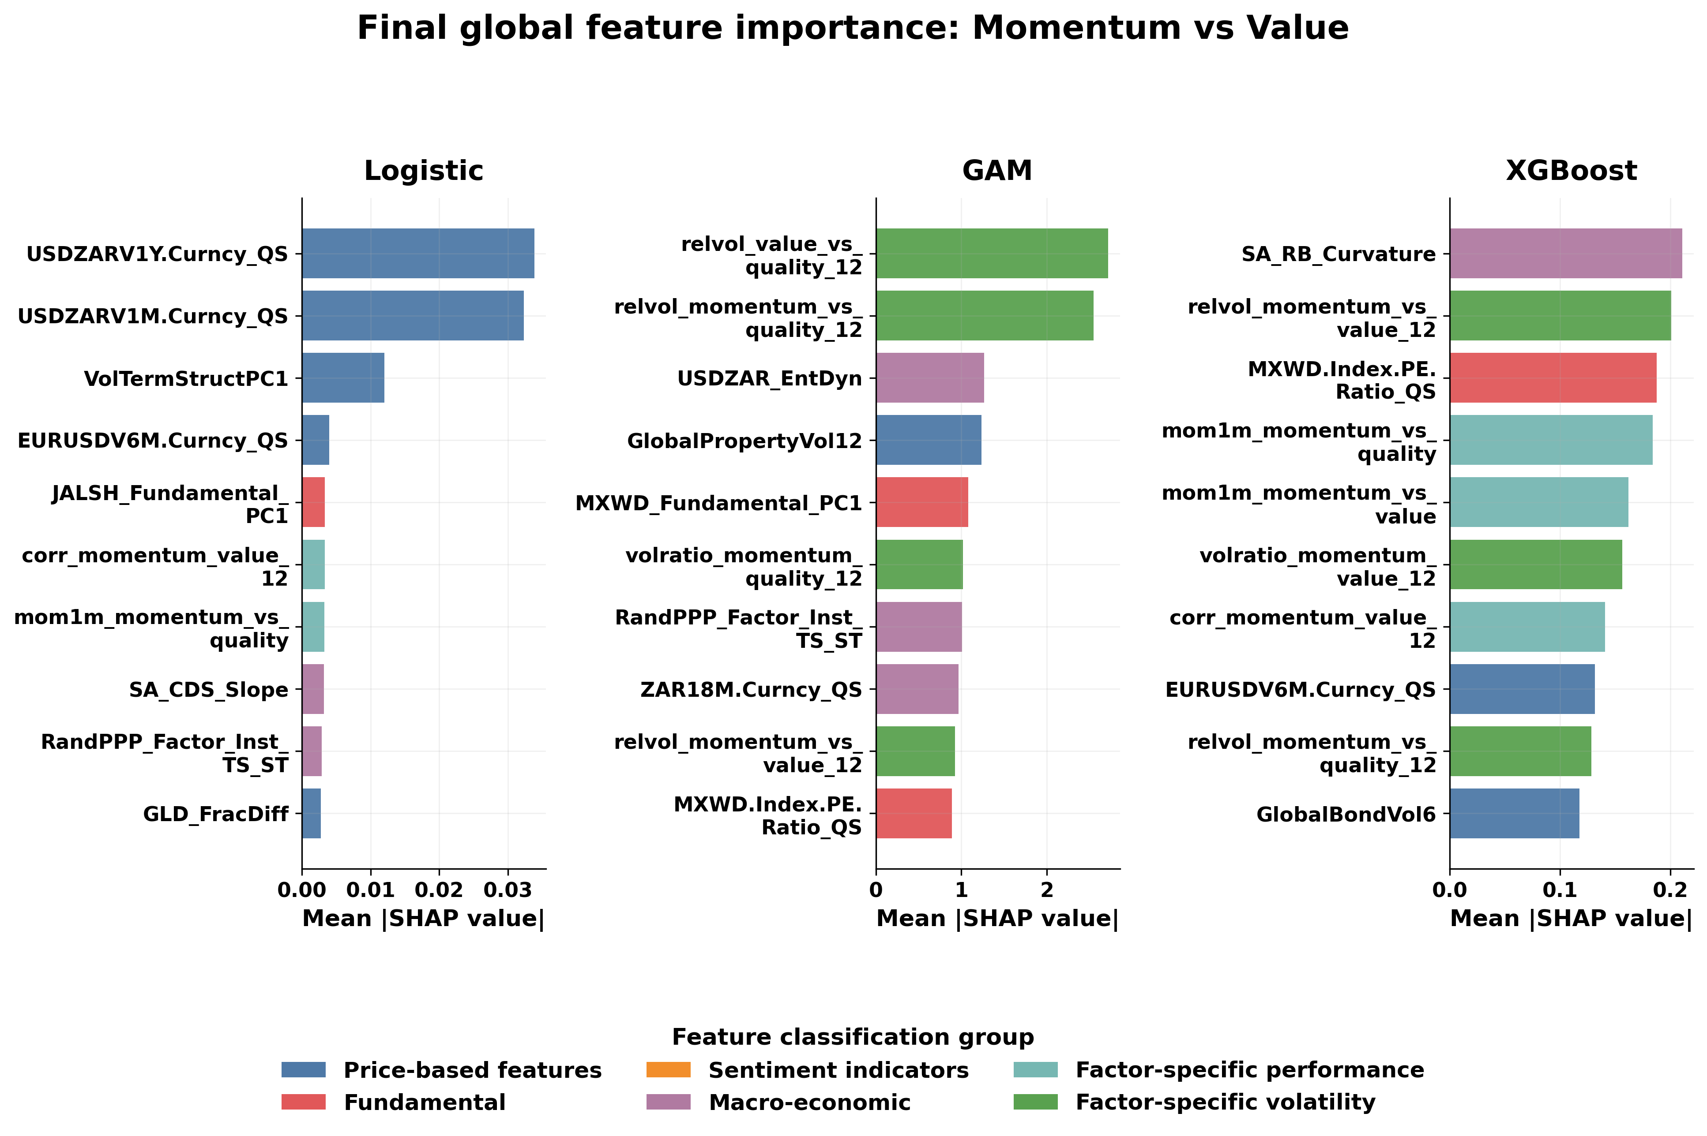
Figure 4.3. Final global SHAP importance for momentum versus value.

Logistic regression is dominated by currency-volatility and volatility-term-structure variables. The GAM places the greatest weight on relative-volatility measures, followed by foreign-exchange entropy, global property volatility and a global fundamental component. XGBoost draws on a broader combination of local real-yield-curve curvature, pair-specific relative volatility, global valuation and short-horizon factor momentum (Ehsani & Linnainmaa, 2022; Gupta & Kelly, 2019). The rankings suggest that the nonlinear models represent momentum-versus-value leadership using both factor-specific instability (Barroso & Santa-Clara, 2015; Daniel & Moskowitz, 2016) and wider market-state information.

Momentum versus quality

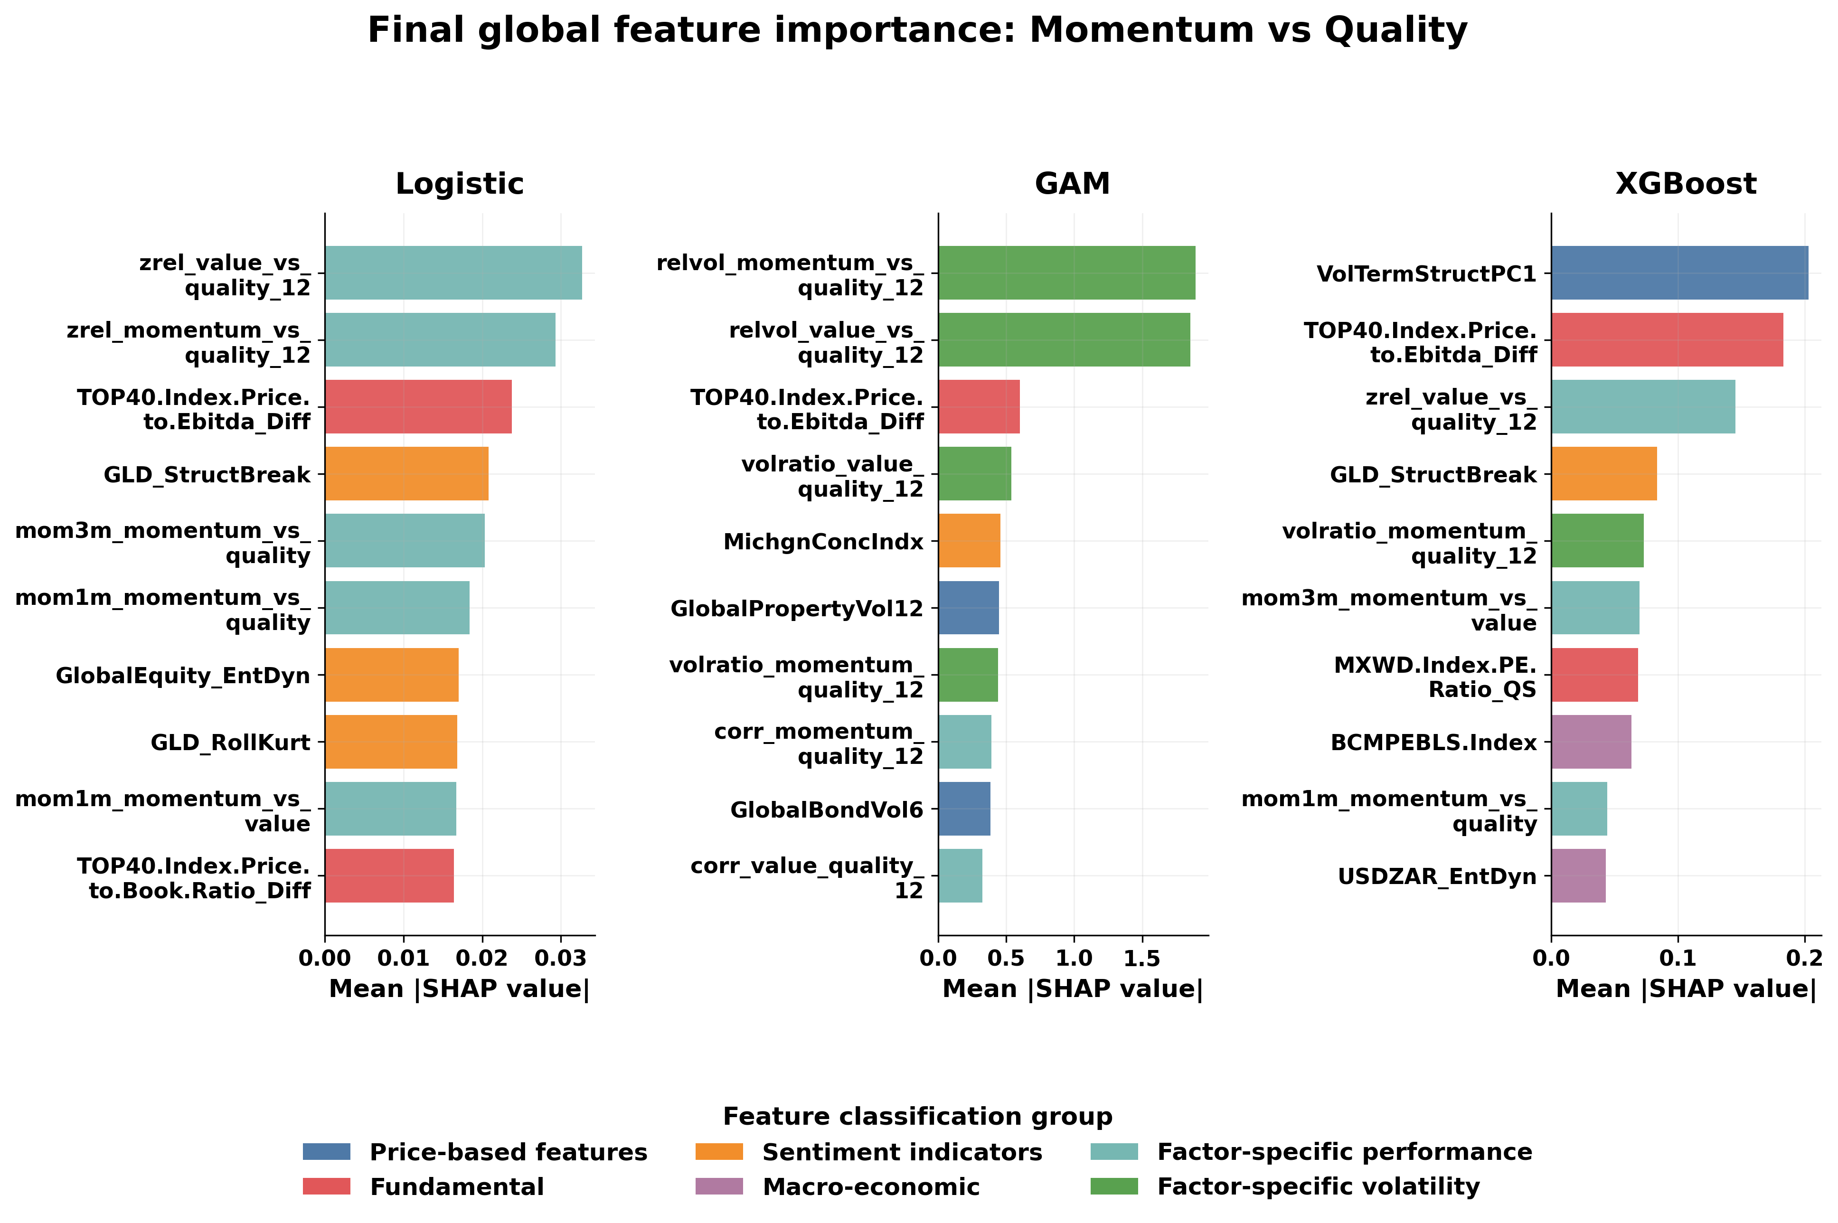
Figure 4.4. Final global SHAP importance for momentum versus quality.

Momentum-versus-quality predictions use a combination of standardised relative performance, relative volatility, valuation, commodity-regime and sentiment information. Relative factor variables appear prominently in all three models, while the local-versus-global EBITDA valuation differential ranks in the top three for each specification, echoing the debate on valuation-based factor timing (Arnott et al., 2016; Asness et al., 2017). Despite this partial overlap, the ordering differs materially across models. The evidence therefore points to multiple representations of the factor pair rather than a single stable driver.

Value versus quality

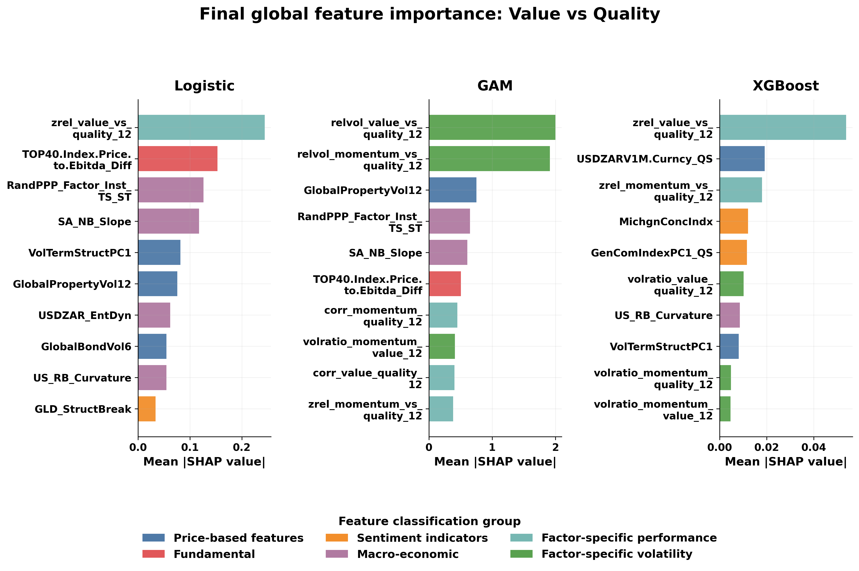
Figure 4.5. Final global SHAP importance for value versus quality.

The standardised value-versus-quality relative-performance measure ranks first for logistic regression and XGBoost, while the GAM is dominated by relative-volatility variables. Valuation, purchasing-power-parity, yield-curve, currency-volatility, sentiment and commodity variables also appear. Logistic regression is the best-performing model for this pair, but its AUC of 0.585 remains modest. The feature rankings should therefore be interpreted as a description of the fitted decision function rather than evidence of stable economic causality.

Chapter conclusion
The final results provide modest and factor-pair-dependent evidence of predictability. XGBoost produces the strongest results for momentum versus value and momentum versus quality, while logistic regression performs best for value versus quality. XGBoost also records the highest mean accuracy and ROC-AUC across the three pairs. Its average advantage does not amount to uniform dominance: logistic regression has the strongest probability quality and leads the value-versus-quality pair, while several models produce strongly asymmetric classifications at the 0.5 threshold.
The findings therefore qualify the proposition that increasing model flexibility necessarily improves out-of-sample prediction (Gu et al., 2020; Kelly et al., 2024). Greater flexibility is beneficial for the two momentum pairs, particularly momentum versus value, but the linear model is more effective for value versus quality. Even the best AUC is below 0.60. The evidence supports limited predictive structure rather than a strongly separable factor-timing signal.
The global SHAP analysis indicates that the fitted models use a combination of relative-factor dynamics, volatility, currency conditions, valuation, yield-curve information, commodity regimes and sentiment. These patterns differ across model classes and factor pairs and should remain exploratory given the modest predictive performance.

Conclusion

Overview of the study
This study investigated whether machine learning methods can enhance the timing of equity style factors in the South African equity market. The empirical analysis focused on three widely documented factors, momentum, value, and quality, and evaluated the feasibility of forecasting their relative performance using supervised learning techniques.
Motivated by the cyclical and regime-dependent nature of factor premia, the study framed the timing problem as a binary classification task predicting the relative outperformance between factor pairs. The modelling framework incorporated several methodological safeguards to ensure statistical robustness. Binary labels were constructed using the trend-scanning procedure proposed by López de Prado, which identifies statistically dominant forward-looking trends without imposing a fixed prediction horizon. The feature universe combined market indicators, macroeconomic variables, sentiment proxies, and valuation measures, reflecting the multidimensional drivers of factor returns documented in the asset pricing literature.
To manage the high dimensionality of the predictor space, mutual-information-based clustering was applied to reduce redundancy while preserving nonlinear dependencies between variables. The predictive performance of three model classes was then evaluated. Hyperparameters were optimized using Combinatorial Purged Cross-Validation (CPCV), and final model performance was assessed using a rolling walk-forward evaluation framework designed to simulate real-time deployment.
Together, this structured empirical framework enabled a disciplined comparison of linear, semi-parametric, and nonlinear modelling approaches for factor timing in an emerging market environment.

Summary of key findings
Several important findings emerge from the empirical analysis.
First, the results demonstrate that machine learning models are capable of extracting predictive signals from the relative dynamics of South African style factors. Across all factor pairs, the nonlinear models consistently outperform the linear benchmark in out-of-sample classification accuracy and ranking ability. This finding supports the growing body of international literature suggesting that factor premia are influenced by complex, nonlinear interactions among market and macroeconomic variables.
Second, predictive performance improves systematically as model flexibility increases. Logistic regression provides the weakest results, indicating that linear functional forms struggle to capture the complex interactions underlying factor rotations. GAM improves predictive performance by allowing smooth nonlinear transformations of predictors, capturing gradual regime effects that linear models cannot represent. XGBoost delivers the strongest results overall, demonstrating the value of flexible tree-based models capable of modelling high-order nonlinearities and interactions among predictors.
Third, the strength of predictability varies across factor pairs. The momentum vs value pair exhibits the strongest predictive structure across all models, suggesting that these two styles experience more pronounced and persistent regime transitions. Momentum vs quality shows moderate predictability, while value vs quality demonstrates the weakest predictive signal. This heterogeneity indicates that factor timing opportunities are not uniform across styles and depend on the structural characteristics of the factor spread.
Fourth, feature importance analysis reveals distinct economic drivers across the factor pairings. The momentum vs value spread is primarily influenced by variables capturing factor instability and dispersion, such as relative volatility and correlation dynamics. Momentum vs quality exhibits a hybrid structure in which factor dispersion signals interact with broader macro-financial conditions. The value vs quality pair is largely anchored in valuation differentials between the two strategies. Despite these differences, dispersion-related variables emerge consistently across models, suggesting that nonlinear dispersion dynamics represent a common structural component of factor interactions.
Fifth, the results highlight the trade-off between predictive accuracy and probability calibration. While XGBoost produces the strongest classification and ranking performance, it also generates less well-calibrated probability forecasts relative to logistic regression. This finding is consistent with prior research demonstrating that highly flexible models often maximize discrimination at the cost of probability reliability.
Finally, the stability of predictive performance across walk-forward windows suggests that the modelling framework successfully mitigates overfitting and temporal leakage. The combination of CPCV hyperparameter tuning and rolling walk-forward evaluation provides a robust validation architecture capable of generating realistic estimates of model performance in financial time-series environments.

Implications for factor timing and quantitative asset management
The findings of this study carry several implications for quantitative asset management and factor-based investment strategies.
First, the results reinforce the notion that factor returns exhibit nonlinear and regime-dependent dynamics. Traditional linear econometric models may therefore be insufficient to capture the complex interactions between macroeconomic conditions, market sentiment, and style factor performance. Machine learning methods provide a flexible alternative capable of approximating these nonlinear relationships.
Second, the results highlight the importance of aligning model complexity with the underlying economic structure of the factor pair. While flexible models such as XGBoost can uncover nonlinear interaction effects, simpler models remain competitive when the predictive structure is largely linear or valuation-driven. The empirical results therefore suggest that model selection should be guided by the economic characteristics of the factor relationship rather than by model complexity alone.
Third, the methodological framework employed in this study demonstrates the value of disciplined validation procedures in financial machine learning applications. Techniques such as purged cross-validation, walk-forward evaluation, and information-theoretic feature reduction are essential to ensure that predictive gains reflect genuine signal rather than artefacts of data leakage or sample-specific noise.
Finally, the study provides empirical support for the potential role of machine learning in dynamic factor allocation. By identifying shifts in relative factor leadership, ML-based models may assist portfolio managers in adjusting exposures across style premia in response to evolving market conditions.

Limitations of the study
Despite these contributions, several limitations should be acknowledged.
First, the analysis focuses on predictive accuracy rather than full portfolio implementation. Transaction costs, turnover, and liquidity constraints were not incorporated into the evaluation framework. These factors may materially affect the realized economic performance of factor timing strategies.
The second limitation relates to the definition of the underlying factor portfolios. In this study, the momentum, value, and quality factors are constructed using proprietary definitions derived from the investment framework of a professional asset manager. While these definitions reflect practical implementation in an institutional investment context, alternative factor constructions may produce different return dynamics and predictive relationships. Prior research has shown that factor performance can vary meaningfully depending on the choice of signals, weighting schemes, rebalancing frequency, and universe definitions. As a result, the predictive relationships identified in this study may depend partly on the specific factor definitions employed.
Furthermore, the study concentrates on three style factors—momentum, value, and quality. While these represent widely validated return premia, other factors such as size, low volatility, or profitability may also exhibit time-varying behaviour that could influence predictive performance. Future research could extend the analysis by testing alternative factor construction methodologies or by comparing results across multiple factor definitions to assess the robustness of the timing signals.
A third limitation relates to the feature selection procedure. The study employs an information-theoretic clustering approach based on mutual information to reduce redundancy in the predictor space. This method groups highly similar variables and selects representative features from each cluster, thereby mitigating multicollinearity and reducing dimensionality. However, the procedure prioritises statistical similarity between predictors rather than their direct predictive contribution to the target variable. As a result, some variables with strong predictive power may be excluded if they belong to clusters dominated by other highly correlated features. While this approach improves model stability and computational efficiency, it may not necessarily produce the feature set that maximises predictive accuracy.
Forth, the empirical analysis is limited to the South African equity market. Although this provides valuable insight into an emerging market context, the results may not generalise fully to other markets with different structural characteristics.
Finally, the modelling framework relies on weekly data and a finite historical sample. Although robust validation procedures were applied, the limited sample size inherent in financial datasets may constrain the stability of highly complex models.

Recommendations for future research
Several avenues for future research emerge from this study.
First, future work should extend the analysis to portfolio implementation by incorporating transaction costs, turnover constraints, and portfolio construction rules. Evaluating the economic value of ML-driven factor timing strategies requires translating predictive signals into investable portfolios.
Second, future research could also explore hybrid feature selection frameworks. While this study employs information-theoretic clustering to reduce redundancy among predictors, the method does not explicitly evaluate the predictive contribution of individual variables. Combining information-based clustering with supervised feature selection techniques may help retain stable feature structures while improving the identification of predictors with strong predictive relevance.
Thirdly, the application of ensemble frameworks that combine predictions from multiple model classes may improve robustness. Hybrid approaches integrating linear models, additive models, and tree-based learners may better balance interpretability and predictive performance.
Finally, future research could explore cross-market generalisation by applying similar methodologies to other emerging markets. Comparative analysis across regions would provide valuable insight into how market structure influences the effectiveness of machine learning in factor timing.

Concluding remarks
This study provides empirical evidence that machine learning techniques can enhance the prediction of relative style factor performance in the South African equity market. By comparing linear, semi-parametric, and nonlinear models within a rigorous validation framework, the research demonstrates that increased model flexibility can yield meaningful improvements in predictive performance. At the same time, the results underscore the importance of disciplined methodological design. Robust validation procedures, careful feature construction, and economically grounded interpretation are essential to ensure that machine learning applications in finance produce reliable and actionable insights. Overall, the findings contribute to the growing literature on financial machine learning and highlight the potential of data-driven approaches for understanding the complex dynamics of factor premia in emerging market

References
Adrian, T., & Brunnermeier, M. (2016). CoVaR. American Economic Review, 1705–1741.
Alonso, M. N., & Zoonekynd, V. (2022). Equity Machine Factor Models. Abu Dhabi: Social Science Research Network.
Ang, A., & Timmermann, A. (2012). Regime changes and financial markets. Annual Review of Financial Economics, 313–337.
Arnott, R., Beck, N., Kalesnik, V., & West, J. (2016). How can "smart beta" go horribly wrong? The Journal of Portfolio Management, 42(2), 36-44.
Arnott, R., Kalesnik, V., & Linnainmaa, J. (2023). Factor momentum. Review of Financial Studies, 36(8), 2379-2420.
Asness, C., Frazzini, A., & Pedersen, L. 2. (2019). Quality minus junk. Review of Accounting Studies, 24(1), 34-112.
Asness, C., Friedman, J., Krail, R., & Liew, J. (2000). Style Timing - Value versus Growth. The Journal of Portfolio Management, 26(3), 1.
Asness, C., Moskowitz, T., & Pedersen, L. (2013). Value and momentum everywhere. The Journal of Finance, 68(3), 929-985.
Bartram, S., Lohre, H., Pope, P., & Ranganathan, A. (2021). Navigating the factor zoo around the world: an institutional investor perspective. Journal of Business Economics, 91(5), 655-703.
Bellman, R. (1957). A Stochastic Multi-Stage Decision Process (1 ed.). New Jersey: Princeton University Press.
Bengio, Y., Simard, P., & Frasconi, P. (1994). Learning long-term dependencies with gradient descent is difficult. IEEE Transactions on Neural Networks, 5(2), 157-166.
Beraha, M., Metelli, A. M., Papini, M., Tirinzoni, A., & & Restelli, M. (2019). Feature Selection via Mutual Information: New Theoretical Insights. (pp. 1-9). Bologna and Italy.: IEEE Xplore.
Bergmeir, C., & Benítez, J. (2012). On the use of cross-validation for time series predictor evaluation. Information Sciences., 192-213.
Bessler, W. (2021). Factor investing and asset allocation strategies. Journal of Asset Management, 22(1), 1-18.
Bishop, C. M. (2006). Pattern Recognition and Machine Learning. (1 ed.). New York: Springer.
Blitz, D. C. (2007). The volatility effect: Lower risk without lower return. Journal of Portfolio Management, 34(1), 102-113.
Blitz, D., Falkenstein, E., & van Vliet, P. (2014). Explanations for the Volatility Effect: An Overview Based on the CAPM Asset Pricing Context. The Journal of Portfolio Management, 40(3), 61-67.
Breiman, L. (1996). Bagging Predictors. Machine Learning, 24(2), 123-140.
Breiman, L. (2001). Random Forests. Machine Learning, 45(1), 5-32.
Breiman, L., Friedman, J., Olshen, R., & Stone, C. (1984). Classification and Regression Trees (1 ed.). New York: Chapman and Hall/CRC.
Brunnermeier, M., & Oehmke, M. (2013). The maturity rat race. Journal of Finance, 483–521.
Bryzgalova, S., Pelger, M., & Zhu, J. (2023). Forest Through the Trees: Building Cross-Sections of Stock Returns. London: S&P Market Intelligence.
Cakici, N., Fieberg, C., Metko, D., & Zaremba, A. (2023). Machine learning goes global: Cross-sectional return predictability in international stock markets. Journal of Economic Dynamics and Control, 155(104725), 1.
Campbell, J. Y., Lo, A. W., & MacKinlay, A. C. (1997). The Econometrics of Financial Markets. (2 ed.). New Jersey: Princeton University Press.
Carhart, M. M. (1997). On Persistence in Mutual Fund Performance. Journal of Finance, 52(1), 57-82.
Carhart, M. M. (1997). On Persistence in Mutual Fund Performance. Journal of Finance, 52(1), 1.
Chen, L., Pelger, M., & Zhu, J. (2019). Deep Learning in Asset Pricing. SSRN Electronic Journal, 1-76.
Chen, T., & Guestrin, C. (2016). XGBoost: A Scalable Tree Boosting System. San Francisco: ACM Digital Library.
Chordia, T., & Shivakumar, L. (2002). Momentum, business cycle, and time-varying expected returns. The Journal of Finance, 57(2), 985-1019.
Chung, J., Gulcehre, C., Cho, K., & Bengio, Y. (2014). Empirical evaluation of gated recurrent neural networks on sequence modeling. arXiv preprint arXiv:1412.3555, 1.
Cochrane, J. (2011). Presidential address: Discount rates. Journal of Finance, 1047–1108.
Cont, R. (2001). Empirical Properties of Asset Returns: Stylized Facts and Statistical Issues. Quantitative Finance, 1(2), 223-236.
Cotturo, P., Liu, F., & Proner, R. (2024). Multi-Factor Timing with Deep Learning. SSRN, 1(1), 1.
Cover, T., & Thomas, J. (2006). Elements of Information Theory. New York: Wiley.
Daniel, K., & Moskowitz, D. J. (2016). Momentum crashes. Journal of Financial Economics, 122(2), 221-247.
Daniel, K., Hirshleifer, D., & Subrahmanyam, A. (1998). Investor Psychology and Security Market Under and Overreactions. Journal of Finance, 53(6), 1839-1885.
DeMiguel, V., Garlappi, L., & Uppal, R. (2009). Optimal versus Naive Diversification: How Inefficient Is the 1/N Portfolio Strategy? The Review of Financial Studies, 22(5), 1915-1953.
Dietterich, T. (2000). Ensemble Methods in Machine Learning. The First International Workshop on Multiple Classifier Systems (pp. 1-15). Berlin: Springer.
Dixon, M., Klabjan, D., & Bang, J. H. (2017). Classification-based Financial Markets Prediction using Deep Neural Networks. Arxiv, 1(1), 1.
Fama, E. F., & French, K. R. (1992). The Cross-Section of Expected Stock Returns. The Journal of Finance, 47(2), 427-465.
Fama, E., & French, K. (1989). Business conditions and expected returns on stocks and bonds. ournal of Financial Economics, 23–49.
Fama, E., & French, K. (1993). Common risk factors in the returns on stocks and bonds. Journal of Financial Economics, 33(1), 3-56.
Fama, E., & French, K. (2015). A five-factor asset pricing model. Journal of Financial, 116(1), 1-22.
Fama, E., & French, K. (2015). A five-factor asset pricing model. Journal of Financial, 116(1), 1-22.
Fang, Y., Chen, Y., & Ren, H. (2022). A Factor Pricing Model Based on Machine Learning Algorithm. Social Science Research Network, 1(1), 1.
Fawcett, T. (2006). An introduction to ROC analysis. Pattern Recognition Letters,, 861–874.
Feng, G., Giglio, S., & Xiu, D. (2020). Taming the Factor Zoo. Journal of Finance, 75(3), 1327-1370.
Feng, G., He, J., Polson, N. G., & Xu, J. (2023). Deep Learning in Characteristics-Sorted Factor Models. Journal of Financial and Quantitative Analysis, 3001-3036.
Fischer, T., & Krauss, C. (2018). Deep learning with long short-term memory networks for financial market predictions. European Journal of Operational Research, 654-669.
Friedman, J. (2001). Greedy function approximation: A gradient boosting machine. The Annals of Statistics, 29(5), 1189-1232.
Giglio, S., Kelly, B., & Xiu, D. (2022). Factor models, machine learning, and asset pricing. Annual Review of Financial Economics, 14(1), 1-32.
Goodfellow, I., Bengio, Y., & Courville, A. (1994). Deep Learning (1 ed.). Cambridge: MIT Press.
Goodfellow, I., Bengio, Y., & Courville, A. (2016). Deep learning. MA: MIT Press.
Gu, S., Kelly, B., & Xiu, D. (2020). Empirical Asset Pricing via Machine Learning. The Review of Financial Studies, Volume 33, Issue 5, 2223–2273.
Gupta, A., & Kelly, B. (2019). Factor momentum everywhere. Journal of Portfolio Management, 45(3), 13-36.
Guyon, I., & Elisseeff, A. (2003). An introduction to variable and feature selection. Journal of Machine Learning Research, 1157–1182.
Han, Y. (2024). Machine Learning Based Portfolio Analysis. Highlights in Business, Economics and Management, 44(1), 1.
Hanley, J. A., & McNeil, B. J. (1982). The meaning and use of the area under a receiver operating characteristic (ROC) curve. Radiology, 29–36.
Harvey, C., Liu, Y., & Zhu, H. (2016). ...and the Cross-Section of Expected Returns. The Review of Financial Studies, 29(1), 5-68.
Hastie, T. J., & Tibshirani, R. (1986). Generalized Additive Models. Statistical Science, 1(3), 297-310.
Hastie, T. T., & Friedman, J. (2009). The Elements of Statisitcal Learning (2 ed.). New York: Springer.
Hastie, T. T., & Friedman, J. (2009). The Elements of Statisitcal Learning (2 ed.). New York: Springer.
Hastie, T., Tibshirani, R., & Friedman, J. (2009). The Elements of Statisitcal Learning (2 ed.). New York: Springer.
Hochreiter, S., & Schmidhuber, J. (1997). Long Short-Term Memory. Neural Computation, 1735–1780.
Hoerl, A. E., & Kennard, R. W. (1970). Ridge regression: Biased estimation for nonorthogonal problems. Technometrics, 12(1), 55-67.
Hosmer, D., Lemeshow, S., & Sturdivant, R. (2013). Applied Logisitc Regression (3 ed.). Hoboken: Wiley.
Huang, D., Li, J., Wang, L., & Zhou, G. (2020). Time-series momentum and macroeconomic risk. Journal of Financial Economics,, 135(1), 160-178.
Ilmanen, A., & Kizer, J. (2012). The death of diversification has been greatly exaggerated. Journal of Portfolio Management, 38(3), 15-27.
Ilmanen, A., Israel, R., Lee, R., Moskowitz, T. J., & Thapar, A. (2021). How do factor premia vary over time? A century of evidence. Journal of Investment Management, 1(1), 1.
Israel, R., Kelly, B., & Moskowitz, T. (2020). Can Machines “Learn” Finance? Annual Review of Financial Economics, 1–25.
Jain, A. K., Murty, M. N., & Flynn, P. J. (1999). Data clustering: A review. ACM Computing Surveys, 31(3), 265-323.
James, G., Witten, D., Hastie, T., & Tibshirani, R. (2021). An Introduction to Statistical Learning (2 ed.). New York: Springer.
Jegadeesh, N., & Titman, S. (1993). Returns to buying winners and selling losers: Implications for stock market efficiency. The Journal of Finance, 48(1), 65-91.
Joseph, A. (2019). Shapley regressions: A framework for statistical inference on machine learning models. London: Bank of England.
Joseph, A. (2024). From interpretability to inference: an estimation framework for universal approximators. arXiv, 1.
Ke, G., Meng, Q., Finley, T., Wang, T., Chen, W., Ma, W., & Liu, T. Y. (2017). Lightgbm: A highly efficient gradient boosting decision tree. Advances in neural information processing systems, 3146-3154.
Kelly, B., Pruitt, S., & Su, Y. (2019). Characteristics are covariances: A unified model of risk and return. Journal of Financial Economics, 501-524.
Koijen, R., Moskowitz, T., Pedersen, L., & Vrugt, E. (2018). Carry. Journal of Financial Economics, 197–225.
Kraskov, A., Stögbauer, H., & Grassberger, P. (2004). Estimating mutual information. Physical Review E, 066138.
Krauss, C., Do, X. A., & Huck, N. (2017). Deep neural networks, gradient-boosted trees, random forests: Statistical arbitrage on the S&P 500. European Journal of Operational Research, 689-702.
Krier, C., François, D., Rossi, F., & Verleysen, M. (2007). Feature clustering and mutual information for the selection of variables in spectral data. Bruges: Proceedings of the European Symposium on Artificial Neural Networks.
Lakonishok, J., Shleifer, A., & Vishny, R. W. (1994). Contrarian investment, extrapolation, and risk. The Journal of Finance,, 49(5), 1541-1578.
Leippold, M., Wang, Q., & Zhou, W. (2021). Machine Learning in the Chinese Stock Market. Journal of Financial Economics, 64–82.
Leung, E., Lohre, H., Mischlich, D., Shea, Y., & Stroh, M. (2021). The Promises and Pitfalls of Machine Learning for Predicting Stock Returns. Lancster: SSRN.
Lim, B., & Zohren, S. (2021). Time-series forecasting with deep learning: a survey. Philosophical Transactions of the Royal Society A, 2194.
Lim, B., Zohren, S., & Roberts, S. (2019). Enhancing Time Series Momentum Strategies Using Deep Neural Networks. The Journal of Financial Data Science, 12(3), 1.
Lintner, J. (1965). The valuation of risk assets and the selection of risky investments in stock portfolios and capital budgets. The Review of Economics and Statistics, 47(1), 13-37.
Liu, S., Li, J., Liu, D., & Wen, T. (2025). Improving Mutual Information based Feature Selection by Boosting Unique Relevance. Journal of Artificial Intelligence Research, 82(1), 129-156.
Lopez de Prado, M. (2018). Advances in Financial Machine Learning (1 ed.). New York: John Wiley & Sons.
Lopez de Prado, M. (2020). Machine Learning for Asset Managers (9 ed.). London: Cambridge University Press.
Lundberg, S. M., & Lee, S. I. (2017). A unified approach to interpreting model predictions. Advances in Neural Information Processing Systems, 4768–4777.
Lundberg, S., Erion, G., Chen, H., DeGrave, A., Prutkin, J., Nair, B., . . . Lee, S. (2020). Explainable AI for Trees: From Local Explanations to Global Understanding. Nature Machine Intelligence, 56–67.
Ma, T., Liao, C., & Jiang, F. (2023). Timing the factor zoo via deep learning: Evidence from China. Accounting & Finance, 63(1), 485-505.
Makamo, S. (2023). Predicting Style Factor Returns and Group/sector Returns Using Long and Short-term Memory ('LSTM') Deep Learning Neural Networks. Johannesburg: SSRN.
Mitchell, T. (1997). Machine Learning (Not Sure ed.). Not sure: McGraw-Hill.
Molnar, C. (2022). Interpretable Machine Learning. Munich: Leanpub.
Moritz, B., & Zimmermann, T. (2016). Tree-Based Conditional Portfolio Sorts: The Relation Between Past and Future Stock Returns. . SSRN Electronic Journal.
Mukoyi, L., & Ogujiuba, K. (2023). Comparison of Multifactor Asset Pricing Models in the South African Stock Market [2000–2016]. Journal of Risk and Financial Management, 16(4), 1.
Murphy, A. (1973). A new vector partition of the probability score. Journal of Applied Meteorology, 595–600.
Niculescu-Mizil, A., & Caruana, R. (2005). Predicting good probabilities with supervised learning. The 22nd international conference on Machine learning (pp. 625-632). Germany: Association for Computing Machinery.
Noguer i Alonso, M., Zoonekynd, V., & Srivastava, S. (2022). Equity Machine Factor Models. Equity Machine Factor Models, 1.
Page, D., McClelland, D., & Auret, C. (2024). Machine learning style rotation – evidence from the Johannesburg Stock Exchange. Cogent Economics & Finance, 12(1), 1-12.
Panda, P. P., Gharanchaei, M. K., Chen, X., & Lyu, H. (2024). APPLICATION OF DEEP LEARNING FOR FACTOR TIMING IN ASSET MANAGEMENT. Pennsylvania: Arxiv.
Peng, H., Long, F., & Ding, C. (2005). Feature selection based on mutual information: criteria of max-dependency, max-relevance, and min-redundancy. IEEE Transactions on Pattern Analysis and Machine Intelligence, 1226–1238.
Piotroski, J. D. (2000). Value Investing: The Use of Historical Financial Statement Information to Separate Winners from Losers. Journal of Accounting Research, 38(1), 1-41.
Piovezan, M., & de Andrea Jr., J. (2022). Machine Learning Method for Return Direction Forecast of Exchange Traded Funds (ETFs) Using Classification and Regression models. Journal of Asset Management,, 23(4), 321-337.
Rumelhart, D., Hinton, G., & Williams, R. (1986). Learning representations by back-propagating errors. Nature, 323(6088), 533–536.
Saetia, K., & Yokrattanasak, J. (2022). Stock Movement Prediction Using Machine Learning Based on Technical Indicators and Google Trend Searches in Thailand. International Journal of Financial Studies, 11(5), 1.
Sagi, O., & Rokach, L. (2018). Ensemble learning: A survey. WIREs Data Mining and Knowledge Discovery, 1249.
Shapley, L. (1953). A value for n-person games. Contributions to the Theory of Games, 307-317.
Sharpe, W. (1964). Capital asset prices: A theory of market equilibrium under conditions of risk. The Journal of Finance, 19(3), 435-442.
Shihao, G., Kelly, B., & Xiu, D. (2020). Empirical Asset Pricing via Machine Learning. The Review of Financial Studies, 33(5), 2223–2273.
Shleifer, A., & Vishny, R. W. (1997). The limits of arbitrage. The Journal of Finance, 52(1), 35-55.
Simonian, J., Wu, C., Itano, D., & Narayanam, V. (2019). A Machine Learning Approach to Risk Factors: A Case Study Using the Fama–French–Carhart Model. The Journal of Financial Data Science, 1(1), 32-44.
Sirignano, J., & Cont, R. (2019). Universal Features of Price Formation in Financial Markets: Perspectives from Deep Learning. Quantitative Finance, 1449-1459.
Štrumbelj, E., & Kononenko, I. (2010). Explaining prediction models and individual predictions with feature contributions. Journal of Machine Learning Research, 1-18.
Sulaiman, N., & Labadin, J. (2016). Improved Feature Selection Based on Mutual Information for Regression Tasks. Indonesian Journal of Electrical Engineering and Computer Science, 4(1), 95-104.
Sutton, R. S., & Barto, A. G. (2018). Reinforcement Learning: An Introduction (2 ed.). Massachusetts: MIT Press.
Tashman, L. J. (2000). Out-of-sample tests of forecasting accuracy: An analysis and review. International Journal of Forecasting, 437-450.
Tibshirina, R. (1996). Regression shrinkage and selection via the lasso. ournal of the Royal Statistical Society: Series B, 58(1), 267-288.
Tobek, O., & Hronec, M. (2021). Does It Pay to Follow Anomalies Research? Machine Learning Approach with International Evidence. Journal of Financial Markets, 58(2021), 1.
Vapnik, N. V. (1999). An Overview of Statistical Learning Theory. TRANSACTIONS ON NEURAL NETWORKS, 10(5), 1.
Vaswani, A., Shazeer, N., Parmar, N., Uszkoreit, J., Jones, L., Gomez, A. N., . . . Polosukhin, I. (2017). Attention is all you need. Advances in neural information processing systems , 5998-6008.
Wang, W. (2023). A comparative study of traditional linear models and nonlinear neural network model on asset pricing. China: Proceedings of the 4th International Conference on Economic Management and Model Engineering .
Ward, J. (1963). Hierarchical grouping to optimize an objective function. Journal of the American Statistical Association, 236–244.
Wolpert, D. (1992). Stacked Generalization. Neural Networks, 241-259.
Wood, S. (2017). Generalized Additive Models - An Introduction with R (2 ed.). New York: Chapman and Hall/CRC.
Wu, H., Wei, X., & Zhang, X. (2021). Are Stock Returns Predictable in China? A Machine Learning Approach. SSRN, 1(1), 1.
Zou, H., & Hastie, T. (2005). Regularization and variable selection via the elastic net. Journal of the Royal Statistical Society: Series B (Statistical Methodology), 67(2), 301-320.

Appendix A: Features Definitions

A.1: Market Data Feature Definitions
Yield Curve Factors (Nominal & Real)
Variable | Description
US_NB_Level_TS | US nominal yield curve level factor (Nelson–Siegel)
US_NB_Slope_TS | US nominal yield curve slope factor
US_NB_Curvature_TS | US nominal yield curve curvature factor
US_RB_Level_TS | US real yield curve level factor
US_RB_Slope_TS | US real yield curve slope factor
SA_NB_Level_TS | SA nominal yield curve level factor
SA_NB_Slope_TS | SA nominal yield curve slope factor
SA_NB_Curvature_TS | SA nominal yield curve curvature factor
SA_RB_Level_TS | SA real yield curve level factor
SA_RB_Slope_TS | SA real yield curve slope factor
SA_RB_Curvature_TS | SA real yield curve curvature factor
FX Level, Returns & Volatility:
Variable | Description
USDZARTS | USD/ZAR exchange rate level
USDZARGret1/3/6/12 | 1–12 month geometric returns – USD/ZAR
USDZARVol1/3/6/12 | 1–12 month rolling volatility – USD/ZAR
USDZARSB | Structural break indicator – USD/ZAR
DXY_TS | US Dollar Index level
DXY_RV_3/12 | 3–12 month realised volatility – DXY
DXY_QuantScale | Quantile-scaled US Dollar Index
Cross-Asset Entropy Measures:
Variable | Description
MultiAssetEnt | Aggregate cross-asset entropy
USDZAR_Ent / EntDyn | USD/ZAR entropy and change
LocalBonds_Ent / EntDyn | SA bond market entropy and change
GlobalBonds_Ent / EntDyn | Global bond market entropy and change
LocalEquity_Ent / EntDyn | SA equity entropy and change
GlobalEquity_Ent / EntDyn | Global equity entropy and change
Asset Class Returns, Volatility & Structural Breaks:
Variable | Description
LocalEquityTS | SA equity index level
LocalEquityGret1/3/6/12 | Geometric returns – SA equity
LocalEquityVol1/3/6/12 | Rolling volatility – SA equity
LocalEquitySB | Structural break – SA equity
GlobalEquityTS | Global equity index level
GlobalEquityGret1/3/6/12 | Geometric returns – global equity
GlobalEquityVol1/3/6/12 | Rolling volatility – global equity
GlobalEquitySB | Structural break – global equity
Cross-Asset Correlation Measures:
Variable | Description
LE_LB_Corr | Correlation: SA equity vs SA bonds
GE_GB_Corr | Correlation: global equity vs global bonds
GE_LE_Corr | Correlation: global vs SA equity
GB_LB_Corr | Correlation: global vs SA bonds
LB_GB_Corr | Correlation: local vs global bonds
Volatility & Risk Indicators:
Variable | Description
VIX.Index | US equity implied volatility index
VIX3M/6M/1Y.Index | Medium- and long-term implied volatility indices
VolTermStructPC1/PC2 | Equity volatility term structure components
SKEW | Equity tail risk premium index
MOVEStructBreak | US Treasury volatility regime shift
Commodity Market Indicators:
Variable | Description
GenComIndexPC1/PC2 | Broad commodity index principal components
CL1FracDiff | Fractionally differenced oil price
GLD_FracDiff | Fractionally differenced gold price
GLD_RollSD/Skew/Kurt | Rolling moments – gold
Macroeconomic & Sentiment Indicators:
Variable | Description
SA_PMI_TS | South African Purchasing Managers’ Index
LEI.Totl_TS | US Leading Economic Indicator
AAII_Bull_TS | US retail bullish sentiment index
SA_BE_Infl | South African breakeven inflation
SA_US_BEInfl_Sprd | SA–US breakeven inflation spread
Composite Principal Components:
Variable | Description
SubIndex_PC1 | First principal component of composite sub-index
SubIndex_PC2 | Second principal component
SubIndex_PC1_TS | Time series of first principal component

A.2: Fundamental Data Feature
S&P 500 Valuation Metrics (Level Adjustments & Quantile Scaling):
Variable | Description
SPX_PX_TO_CASH_FLOW_Diff | First difference of S&P 500 price-to-cash-flow ratio
SPX_PX_TO_SALES_RATIO_Diff | First difference of S&P 500 price-to-sales ratio
SPX_PX_TO_BOOK_RATIO_Diff | First difference of S&P 500 price-to-book ratio
SPX_PE_RATIO_Diff | First difference of S&P 500 price-to-earnings ratio
SPX_PX_TO_EBITDA_Diff | First difference of S&P 500 price-to-EBITDA ratio
SPX_PX_TO_CASH_FLOW_QS | Quantile-scaled S&P 500 price-to-cash-flow ratio
SPX_PX_TO_SALES_RATIO_QS | Quantile-scaled S&P 500 price-to-sales ratio
SPX_PX_TO_BOOK_RATIO_QS | Quantile-scaled S&P 500 price-to-book ratio
SPX_PE_RATIO_QS | Quantile-scaled S&P 500 price-to-earnings ratio
SPX_PX_TO_EBITDA_QS | Quantile-scaled S&P 500 price-to-EBITDA ratio
EarningSpread_SPX | S&P 500 earnings yield minus bond yield spread
JALSH Valuation Metrics (Level Adjustments & Quantile Scaling):
Variable | Description
JALSH_PX_TO_CASH_FLOW_Diff | First difference of JALSH price-to-cash-flow ratio
JALSH_PX_TO_SALES_RATIO_Diff | First difference of JALSH price-to-sales ratio
JALSH_PX_TO_BOOK_RATIO_Diff | First difference of JALSH price-to-book ratio
JALSH_PE_RATIO_Diff | First difference of JALSH price-to-earnings ratio
JALSH_PX_TO_EBITDA_Diff | First difference of JALSH price-to-EBITDA ratio
JALSH_PX_TO_CASH_FLOW_QS | Quantile-scaled JALSH price-to-cash-flow ratio
JALSH_PX_TO_SALES_RATIO_QS | Quantile-scaled JALSH price-to-sales ratio
JALSH_PX_TO_BOOK_RATIO_QS | Quantile-scaled JALSH price-to-book ratio
JALSH_PE_RATIO_QS | Quantile-scaled JALSH price-to-earnings ratio
JALSH_PX_TO_EBITDA_QS | Quantile-scaled JALSH price-to-EBITDA ratio
EarningSpread_JASLH | JALSH earnings yield minus bond yield spread
Relative Valuation & Cross-Market Spreads:
Variable | Description
ValuationSpreadLocalGlobal | Valuation differential between local (JALSH) and global (S&P 500) equity markets
Sentiment & Policy Uncertainty Indicators:
Variable | Description
AAIIBULL.Index | AAII bullish investor sentiment index
AAIIBEAR.Index | AAII bearish investor sentiment index
EPUCCUSM.Index | US Economic Policy Uncertainty index

A.3: Economic Data Feature Definitions
Sovereign Credit Risk Indicators:
Variable | Description
RepSouCDSCurve_PC1/PC2/PC3 | Principal components of SA sovereign CDS term structure
RepSouCDSCurve_QS_PC1/PC2/PC3 | Quantile-scaled CDS term structure principal components
REPSOU_5YR_CDS | 5-year South African sovereign CDS spread
US Yield Curve Factors (Nominal & Real):
Variable | Description
US_NB_Level | US nominal yield curve level factor
US_NB_Slope | US nominal yield curve slope factor
US_NB_Curvature | US nominal yield curve curvature factor
US_NB_Lambda | Decay parameter of US nominal yield curve (Nelson–Siegel)
US_NB_R2 | Goodness-of-fit measure of nominal yield curve model
US_NB_Level_QS / Slope_QS / Curvature_QS | Quantile-scaled nominal yield curve factors
US_NB_Lambda_QS / R2_QS | Quantile-scaled decay and fit measures
US_RB_Level | US real yield curve level factor
US_RB_Slope | US real yield curve slope factor
US_RB_QS_Level / QS_Slope | Quantile-scaled real yield curve factors
South African Yield Curve Factors
Variable | Description
SA_NB_Level / Slope / Curvature | SA nominal yield curve factors
SA_NB_Lambda | Decay parameter – SA nominal yield curve
SA_NB_R2 | Fit statistic – SA nominal yield curve
SA_NB_Level_QS / Slope_QS / Curvature_QS | Quantile-scaled SA nominal curve factors
SA_NB_Lambda_QS / R2_QS | Quantile-scaled decay and fit measures
SA_RB_Level / Slope / Curvature | SA real yield curve factors
SA_RB_Lambda | Decay parameter – SA real yield curve
SA_RB_R2 | Fit statistic – SA real yield curve
SA_RB_Level_QS / Slope_QS / Curvature_QS | Quantile-scaled SA real curve factors
SA_RB_Lambda_QS / R2_QS | Quantile-scaled decay and fit measures
South African Macro Activity Indicators:
Variable | Description
SAPMI_YoY | SA Purchasing Managers' Index – year-on-year change
SACWC_YoY | SA composite leading indicator – year-on-year change
OEZAA013_YoY | SA economic activity indicator – year-on-year change
Economic Surprise Indices:
Variable | Description
CESIUSD.Index | US Citi Economic Surprise Index
CESIEM.Index | Emerging Markets Economic Surprise Index
CESIGL.Index | Global Economic Surprise Index
EcoSrpCITI_PC1/PC2 | Principal components of economic surprise indices
InflGrowthSurpPC1/PC2 | Principal components of inflation and growth surprise factors
InflGrowthSurpPC1_QS / PC2_QS | Quantile-scaled inflation-growth surprise components
Global Activity & Confidence Indicators:
Variable | Description
BCMPEBLS.Index | US business cycle momentum index
LEI.TOTL.Index | US Leading Economic Indicator
CONCCONF.Index | US Conference Board Consumer Confidence
SSICCONF.Index | South African consumer confidence index
TINSALNL.Index | US total industry sales indicator
OPCVTPCR.Index | US capacity utilisation indicator
Sentiment & Purchasing Power Parity Indicators:
Variable | Description
MichgnConcIndx | University of Michigan Consumer Sentiment Index
MichgnConcIndx_TS | Time series of Michigan consumer sentiment
MichgnConcIndx_QuantileScale | Quantile-scaled Michigan sentiment index
RandPPP_Factor_Inst | Rand purchasing power parity factor
RandPPP_Factor_Inst_TS_ST | Short-term PPP factor time series
RandPPP_Factor_Inst_TS_LT | Long-term PPP factor time series
RandPPP_QuantileScale | Quantile-scaled PPP factor

A.4. Relative Factor Interaction Metrics
Variable | Description
zrel_momentum_vs_value_12 | 12-month z-scored relative performance: Momentum vs Value
relvol_momentum_vs_value_12 | 12-month relative volatility: Momentum vs Value
corr_momentum_value_12 | 12-month rolling correlation: Momentum vs Value
volratio_momentum_value_12 | 12-month volatility ratio: Momentum vs Value
mom1m_momentum_vs_value | 1-month relative return: Momentum vs Value
mom3m_momentum_vs_value | 3-month relative return: Momentum vs Value
zrel_momentum_vs_quality_12 | 12-month z-scored relative performance: Momentum vs Quality
relvol_momentum_vs_quality_12 | 12-month relative volatility: Momentum vs Quality
corr_momentum_quality_12 | 12-month rolling correlation: Momentum vs Quality
volratio_momentum_quality_12 | 12-month volatility ratio: Momentum vs Quality
mom1m_momentum_vs_quality | 1-month relative return: Momentum vs Quality
mom3m_momentum_vs_quality | 3-month relative return: Momentum vs Quality
zrel_value_vs_quality_12 | 12-month z-scored relative performance: Value vs Quality
relvol_value_vs_quality_12 | 12-month relative volatility: Value vs Quality
corr_value_quality_12 | 12-month rolling correlation: Value vs Quality
volratio_value_quality_12 | 12-month volatility ratio: Value vs Quality
mom1m_value_vs_quality | 1-month relative return: Value vs Quality
mom3m_value_vs_quality | 3-month relative return: Value vs Quality

Appendix B: Feature Selection

B.1. Clusters and Cluster Representatives:

[work in progress]

Appendix C: CPCV and Walk-forward Formulation
[work in progress]

The relative weights of the descriptors within each factor are proprietary to Momentum Investments and are not published, so the factor composites cannot be replicated exactly from public information.
The feature file spans 944 weeks, from 5 March 2007 to 31 March 2025; the 12-week rolling windows of the relative-factor features remove the first 11 (944 − 11 = 933), and the four-week lag removes a further four (933 − 4 = 929), so the matrix begins on 18 June 2007. Trend-scanning labels cannot be resolved for the final ten weeks, leaving 919 labelled observations per factor pair (18 June 2007 to 20 January 2025)
MI is estimated after discretising each series into 20 quantile bins and normalised by the larger of the two marginal entropies; the distance is one minus the normalised MI. The Ward clustering is applied to each feature’s profile of distances to all other features, so the cut height of 2 is measured on these profiles rather than on MI distance itself. Appendix B reports the clusters and the sensitivity of the selection to these choices.

